Subsidiary Mathematics
SENIOR FIVE term 2

TOPIC 1/4: Descriptive Statistics
Competency: The learner applies indices and logarithms to solve societal problems involving exponential relationships and scaling in various fields. Indices
There are five basic rules of indices 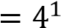
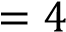
(a) 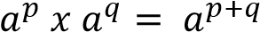 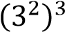
( c )
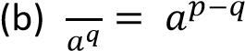 Solution
(c) 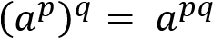 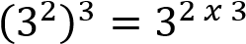
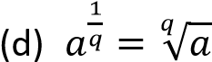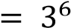
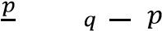
(e) 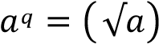
Example 1 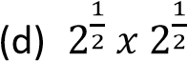
Solution
Evaluate the following 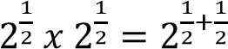

(a) 2² x 2³ 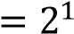
Solution

2² x 2³ = 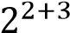 (e) 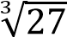
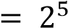 Solution
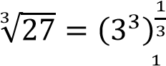
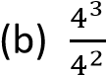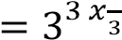
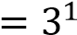
Solution
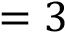
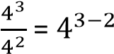

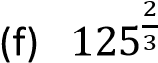
Solution
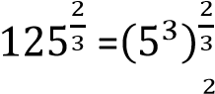
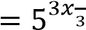
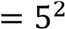
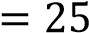
Example 2
Evaluate the following
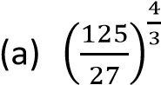
Solution
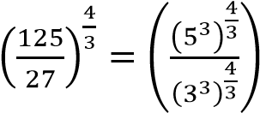
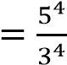
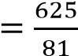

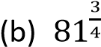
Solution
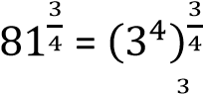
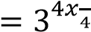
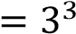
= 27

The zero index
From 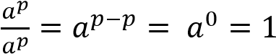
Any number raised to power zero =1
i.e. 100⁰ = 529⁰ = 83⁰ = 1 Negative indices
It can be shown that
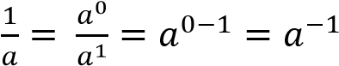
Also
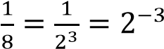
Hence a negative index is the inverse of a given number
Example 3
Evaluate the following
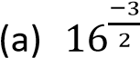
Solution
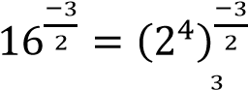
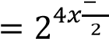
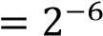
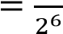
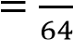
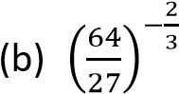
Solution
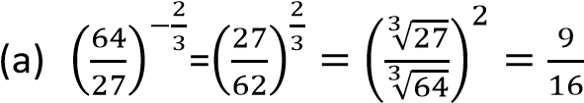
Example 4
Show that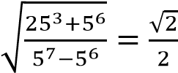
Solution
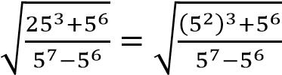
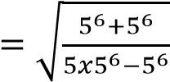
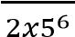
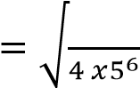
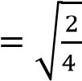

√
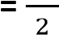(as required)

Solving equations with unknown indices
It involves making appropriate substitution after expressing terms containing powers in simplified form Example 5
Solve the equation
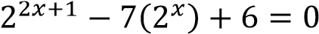
Solution
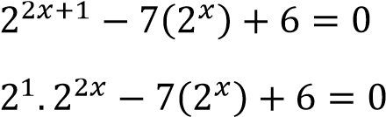
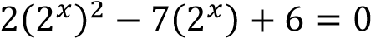
Let p = 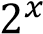
⇨ 2p² – 7p + 6 = 0
(2p – 3)(p – 2) = 0 Either 2p -3 = 0 p = or p – 2 =0 p = 2
when p= 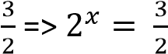
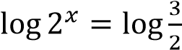
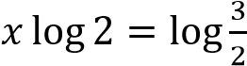
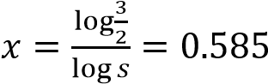
When p = 2
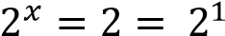
x = 1
Hence x = 1 and x = 0.585 (3d.p)

Example 6
Show that
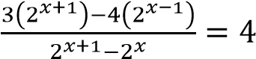
Solution
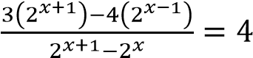
Handling terms on the LHS
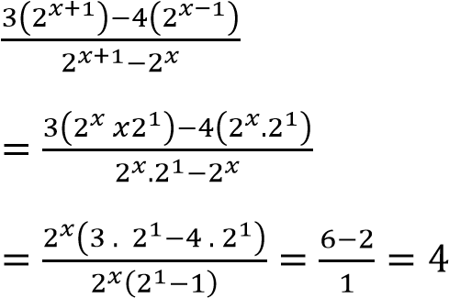
Example 7
Solve 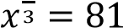
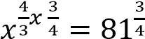
x = 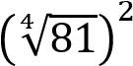= 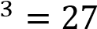

Solving equations with squares
Example 8
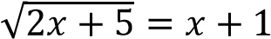
Square both sides
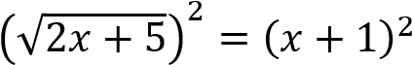
2x + 5 = x²+ 2x + 1 x² = 4
x = 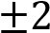
Testing/checking using -2
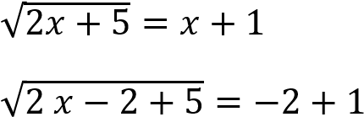
1 -1
Hence -2 is not a solution to the equation Testing/checking using 2
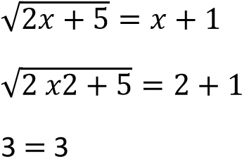
Hence 2 is the solution to the equation
Example 9
Solve for x: 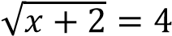
Square both sides
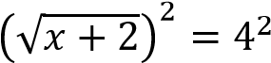
x + 2 = 16 x = 14

Finding square roots of terms containing rational and irrational quantities
When finding roots of terms expressed in the

form a + √ , where a is a rational and b is an irrational quantity, we let the root to be in the
form of 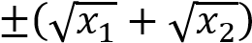 where x₁ and x₂ are integers.
Example 8

Find the square root of 6 +2√

Let 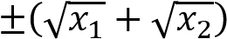 be square root of 6 +2√
⇨ 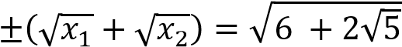
Squaring both sides
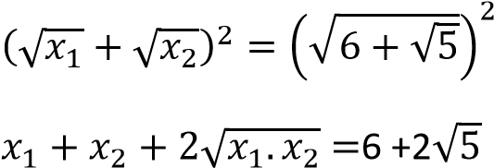
Comparing terms on the two sides
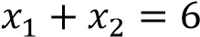
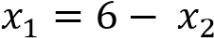 ………………..(i)
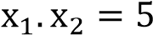…………………….(ii)
Substituting eqn. (i) into eqn. (ii)
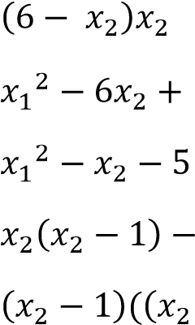 = 5
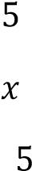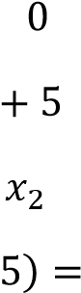
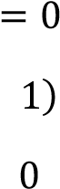
(

Either: 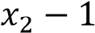 = 0 => 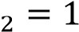
Or 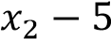 = 0 => 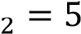
When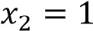: 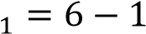 = 5
When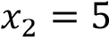: 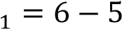 = 1
Hence the square root of 6 +2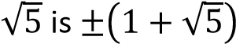
Example 10
Find the square root of 8 - 2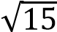
et 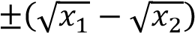 be square root of 8 -2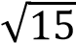
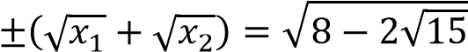
Squaring both sides
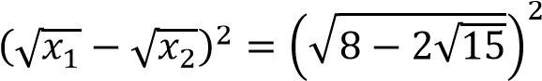
Comparing terms on the two sides
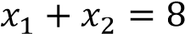
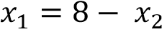 ………………..(i)
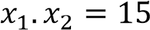…………………….(ii)
Substituting eqn. (i) into eqn. (ii)
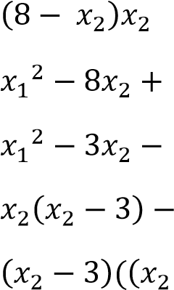 = 15
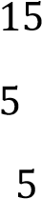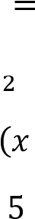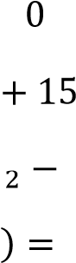
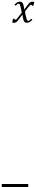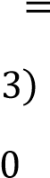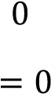

Either: 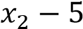 = 0 => 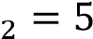
Or 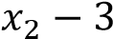 = 0 => 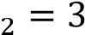
When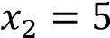: 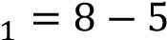 = 3
When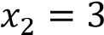: 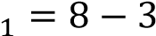 = 5
Hence the square root of 8 -2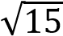 is 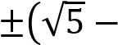
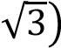

Revision exercise 1
- Simplify
(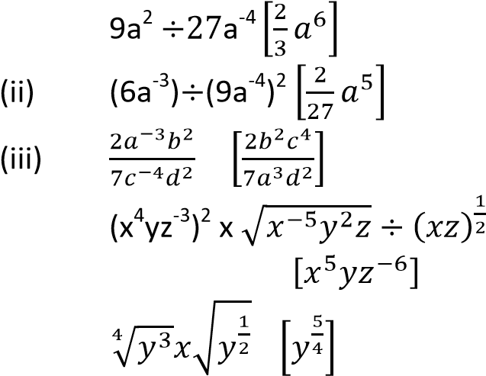i)
(iv)
(v)
- Evaluate
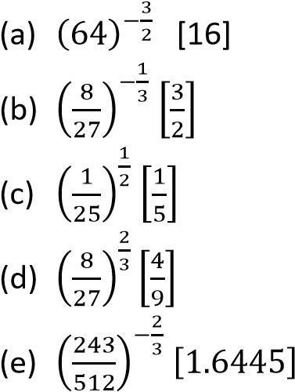
- Solve the following equations
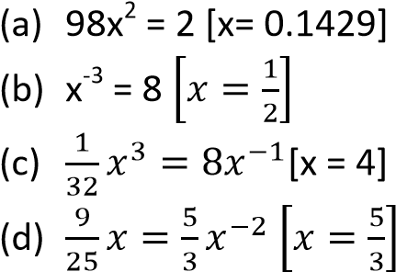
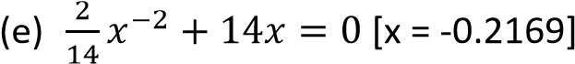
- Solve for x
(a) 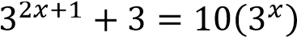 [x = 1 or x = -1]
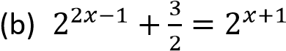[x =0, x =1.585]
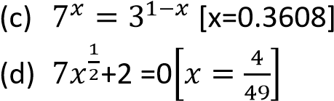
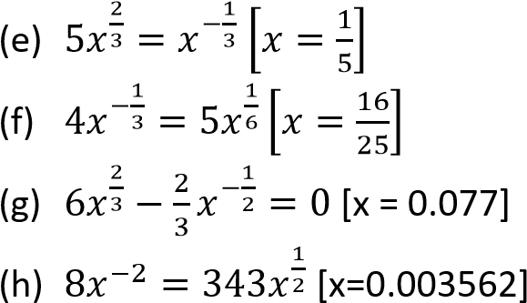
- Show that
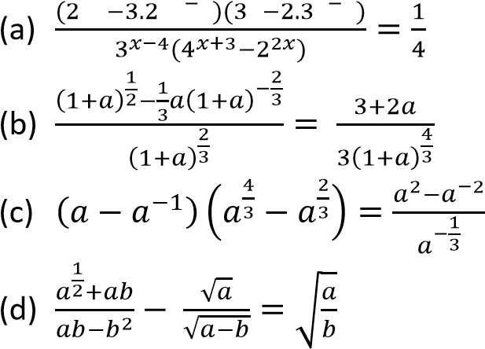
- Solve
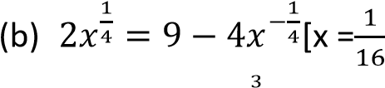, x = 256]
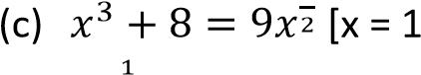, x= 4]
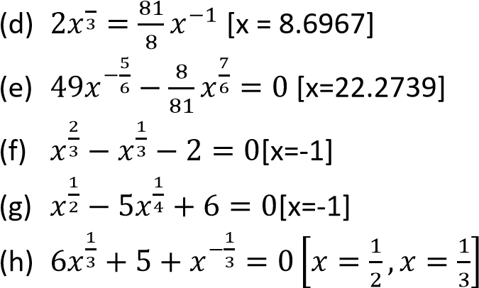
- Solve for x
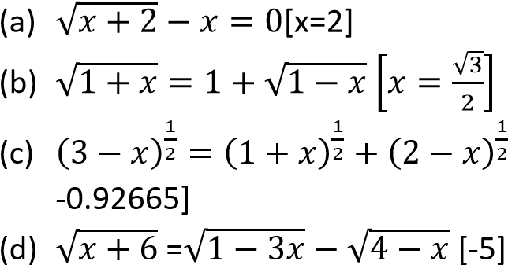[x =
- Without using mathematical tables or calculators, find the value of
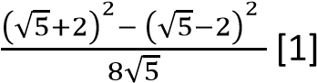
- Find the square root of the following
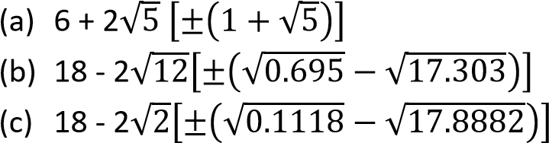
Examples exponential growth and decay that reduce to quadratics, using the laws of indices

and interpret the solutions within context.
Exponential equations can sometimes be transformed into quadratic equations using the laws of indices and a suitable variable substitution. The solutions to the resulting quadratic equation must then be interpreted in the context of the original exponential problem, particularly ruling out non-physical results like negative amounts or impossible timeframes.
Example 11
A bacteria culture's growth is modeled by the equation 4^{t}−20(2^{t})+64= 0, where t is the time in hours and the population is related to powers of 2. find the time(s) t when the population reaches a certain state.

Solution

Applying laws of indices
4^{t} = 2^{2t} = (2^{t})²
The equation becomes
(2^{t})²−20(2^{t})+64= 0,
Let x = 2^{t} Substituting x for 2^{t} x² + 20x + 64 = 0

Solving quadratic equation
(x – 4)(x – 16) = 0
Either x – 4 = 0; x = 4
Or (x – 16) = 0 ; x = 16

Reversing substitution
For x = 4, 2^{t} = 4 = 2²; t =2 For x = 16, 2^{t} = 16 = 2⁴; t =4

Interpretation:
Both solutions, t = 2hours and t= 4hours are positive and physically possible. This means the bacteria population level described by the equation occurs at two different points in time, perhaps indicating the population rises, peaks, and falls due to resource limitations (though the initial model might be a simplified representation). Example 12
A rural livestock population grows geometrically: P_{t}=P₀b^{t}. Field data suggests each season’s herd equals the sum of the previous two seasons’ herds (a “Fibonaccilike” recurrence): P_{t}=P_{t−1}+P_{t−2}. Find the value of b

Derivation using indices:
Write all terms with the exponential form:
P0bt = P0bt-1 + P0bt-2
Divide through by P₀b^{t−2}:
b² = b + 1 Rearranging
b² - b - 1 = 0
Solving quadratic equation
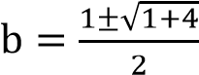
either b = 1.618 or -0.618
Since the base b is a growth multiplier per season, so b>0, we discard the negative value. A negative base is not meaningful for herd size, and b<1 would imply decay (contradicting the recurrence).
Hence the value of b = 1.618
Interpretation: The herd grows by about 61.8% each season.
Example 13
A radioactive substance's remaining mass
(in grams) is described by the equation 9^{x}−12(3^{x})+27=0 is the number of half-lives passed. Find the number of half-lives for a specific remaining mass. Solution

Applying laws of indices
9^{t} = 3^{2t} = (3^{t})²
The equation becomes
(3^{t})²− 12(2^{t}) + 27= 0,
Let x = 3^{t} Substituting x for 3^{t} x² + 12x + 27 = 0

Solving quadratic equation
(x – 3)(x – 9) = 0
Either x – 3 = 0; x = 3
Or (x – 9) = 0 ; x = 9

Reversing substitution
For x = 3: 3^{t} = 3 = 3¹; t = 1
For x = 9: 3^{t} = 9 = 3² ; t = 2

Interpretation:
The solutions are t = 1 and t = 2 half-lives. Both values are positive and meaningful in the context of time passing. The substance reaches the specific mass level after 1 halflife and again after 2 half-lives. This might happen if the "remaining mass" value in the equation is an intermediate value the substance passes through during its decay process.
Example 14
A community’s clean water supply capacity S(t) is being upgraded so it scales approximately like S(t)=200 (1.05)^{2t} (two compounding improvements per year), while water demand grows as D(t)=500 (1.05)^{t} . When will supply and demand balance?

Solution
The supply and demand will balance when
S(t) = D(t)
200 (1.05)^{2t} = 500 (1.05)^{t}
Substituting x = (1.05)^{t} the equation becomes
200x² = 500x
200x² - 500x= 0
x(200x – 500) = 0 x = 0 or x = 2.5

Discard x = 0 (not possible since x=(1.05)^{t}>0).
Reverse substation
(1.05)^{t} =2.5
t = 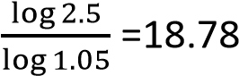

Interpretation
with demand. Logarithms
After about 19 time units (e.g., years if t is in years), the upgraded supply catches up

A logarithm is an exponent, an index or power
The logarithm of a positive quantity p to a given base q is defined as the index or power to which the bases q must be raised to make it equal to P. i.e. or x s the
logarithm of p to base q
- x is the power (index, logarithm or exponent)
- q is the base
- p is the number (which must be positive)
Example 15
Find the values of x in the following
- 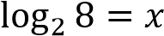
Solution
8 = 2³
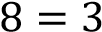; x = 3

- 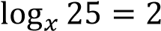 Solution
25 = 5²
⇨ x² = 5²

Example 16
Evaluate
(a) 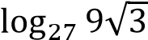
Solution
Let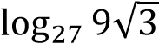 = x
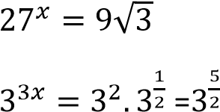
Equating powers
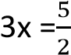
x =
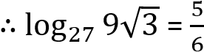

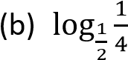
Solution
Let 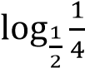= x
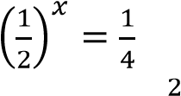
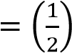
Equating powers x = 2
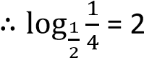
Example 17
Given that log₃x = 2log₃4 –log₃5 + log₃9, find the value of x. (05marks)
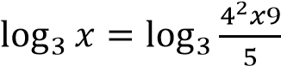
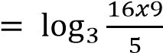
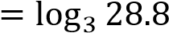
Comparing both sides x = 28.8
Example 18
Given that p = 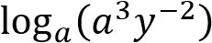 and q = 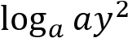, find the value of p + q. (05 marks)
Solution
P + Q = 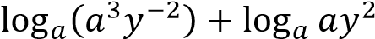
=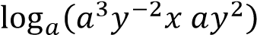
=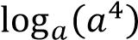
= 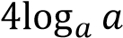
= 4 x 1 = 4
Example 19
Evaluate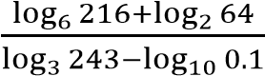
Solution
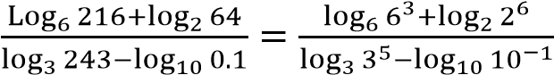
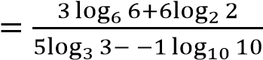
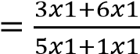
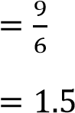
Rules of logarithms
(a) (i) 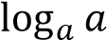 = 1
Proof
Let 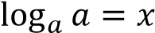
a^{x} = a¹
x = 1
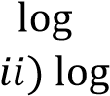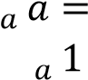
( = 0
Proof
Let 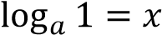
a^{x} = a⁰
x = 0
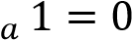
(b) The power rule
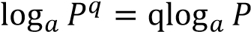
Proof
Let 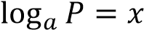
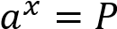
Raising each to the power q
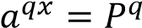
⇨
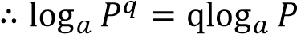

- The addition/multiplication rule
Proof Let
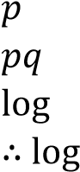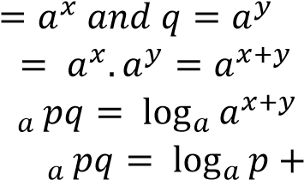

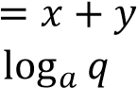

- The subtraction/division rule
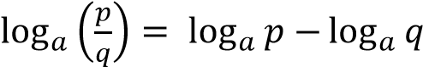
Proof
Let
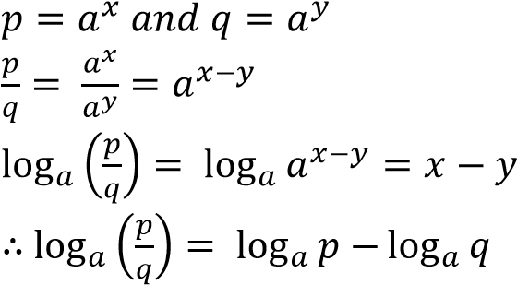

- Change of base
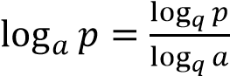
Let 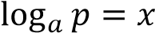, then 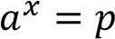
  - 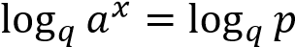
x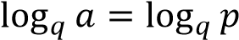
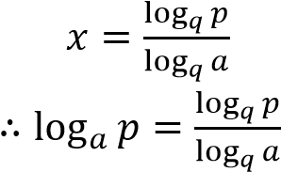
Example 20
Evaluate
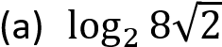
Solution
Either: let 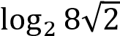= x
  - 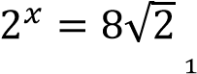
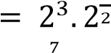
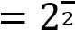
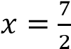
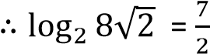
Or 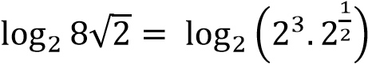
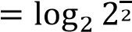
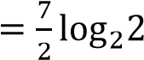
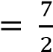

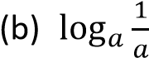
Solution
Let 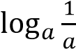= x
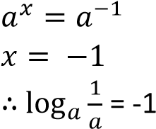
Example 21
Express each of the following as a single logarithm
- Log 4 + log3
Solution
Log 4 + log3 = log (4 x 3)
= log 12

- Log 5 + log 18 – log3
Solution
Log 5 + log 18 – 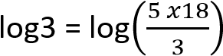
= log30
Example 22
Show that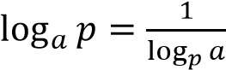. Hence solve the
equation 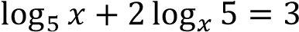
Solution
Let
- 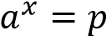
Introducing log to base p on both sides
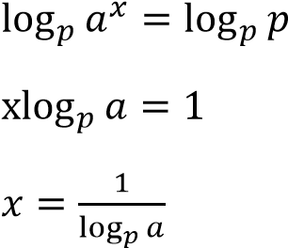
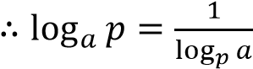
Then,
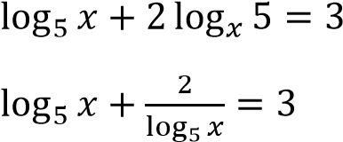
Let y = 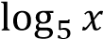
- y + 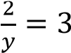
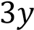
(y – 1)(y – 2) = 0
Either y = 1 or y = 2
When y = 1: 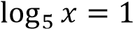; x = 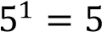
When y = 2: 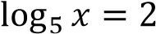; x = 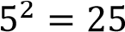
x = 5 and x = 25

Example 23
Solve 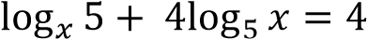
Expressing terms on LHS to log₅.
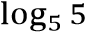
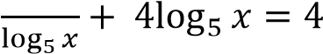
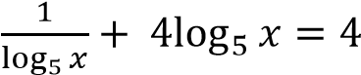
Let 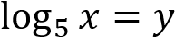
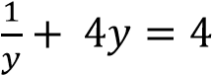
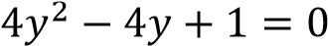
(2y – 1)(2y – 1) = 0
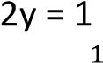 y =
⇨ 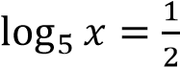
x = 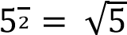

Example 24
Show that 2log4 + 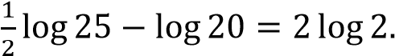
Solution
Handling the left hand side
2log4 + 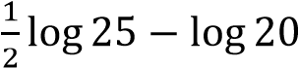
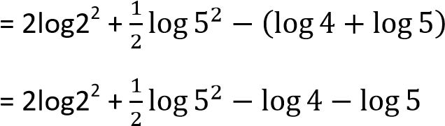
= 4log2 + 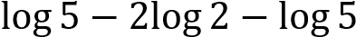
= 2log 2
Example 25
(a) (i) Find without using tables

√

Solution
Let 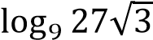 = x
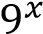 =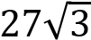
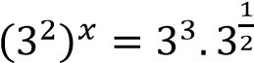
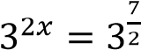
Equating indices
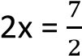
x =1.75
Or
Changing the base from 9 to 3
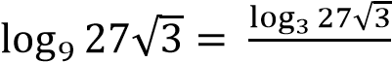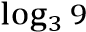

√

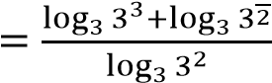
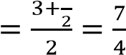
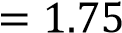

(ii) Simplify 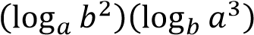
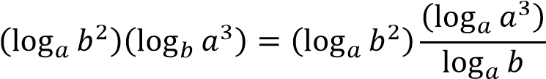
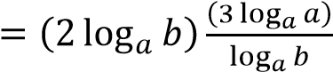
= 2 x 3 = 6
Or
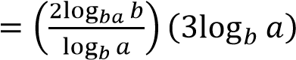
= 2 x 3 = 6
(b) Express 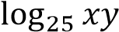 in terms of
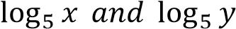. Hence solve the simultaneous equations:
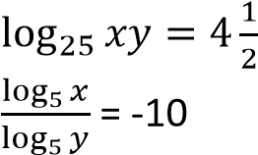
Solution
(ii) By change of base rule
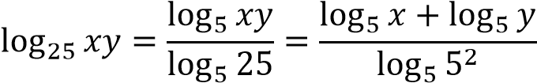
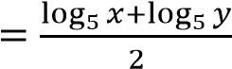
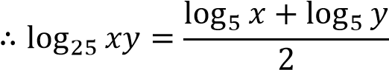
Hence solving
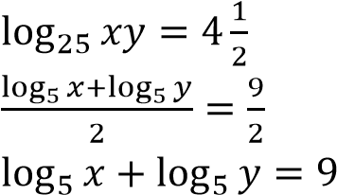 ……………….. (i)

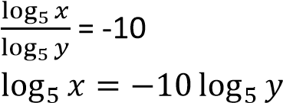 …………….(ii) Substituting eqn. (ii) into eqn. (i)
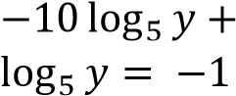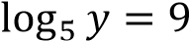

y = 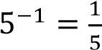
Substituting 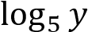 into equation (ii)
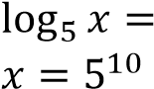

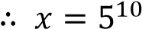 and y 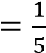

Example 26
- Given that 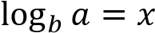 show that b = and deduce 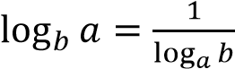
Solution
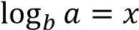
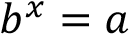
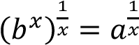
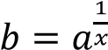
Taking log to base a on both sides
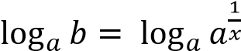
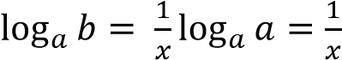
But x = 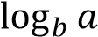
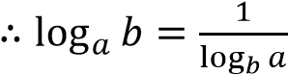

- Find the value of x and y such that
(i) 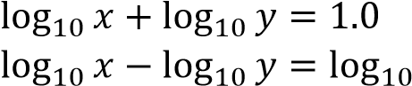 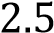
Solution
 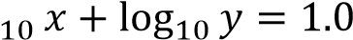 ……………(i)
…(ii)
Eqn. (i) + eqn. (ii)
2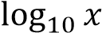 = 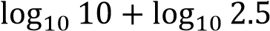
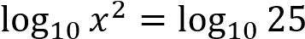
⇨ 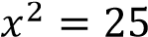 x = 5
Substituting x into eqn. (i)
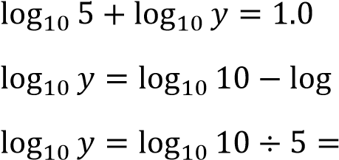
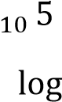
y = 2
Hence x = 5 and y = 2

(ii) Simplify 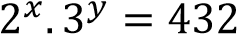
Solution
Comparing exponents
x = 4 and y = 3

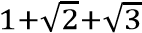
(c) Simplify
√

√

Solution
By rationalizing
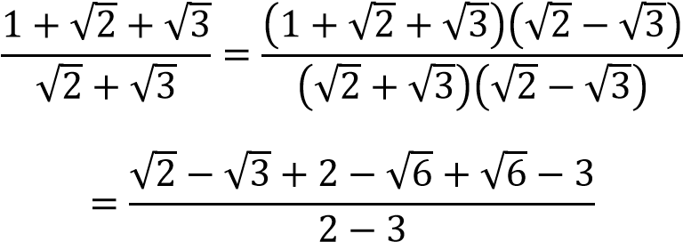
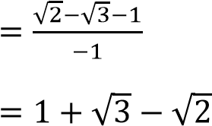
Example 27
Prove that 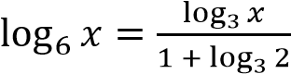. Given that
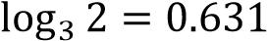, find without using tables or calculator 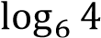 correct to 3significant figures
Solution
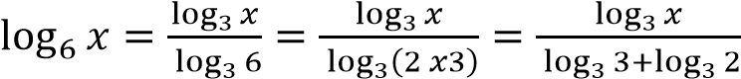
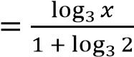
Substituting for 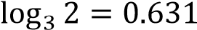
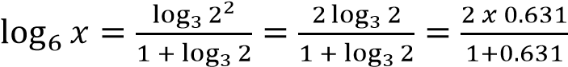
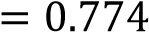

Revision exercise 2
- Evaluate
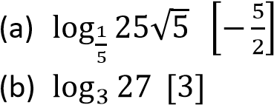
- Express the following as a single logarithm
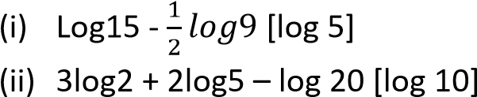 3. Given that 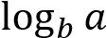 and 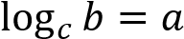, show that
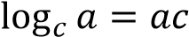
- (a) solve the equation
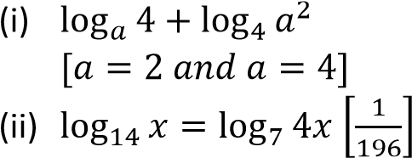
- Without using tables or calculator show that 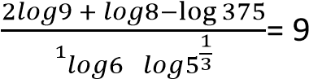
- 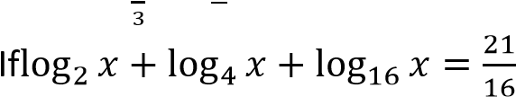. Find the value of x [x = 1.6818]
- Given, show that
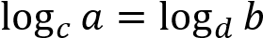. Hence or otherwise solve
the equation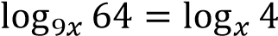. [x=3] 8. Solve the simultaneous equations
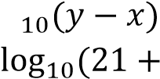= 0
2 [(x,y) =(-5, -4) or (4,5)
- Given that 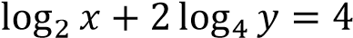. Show that xy = 16. Solve simultaneous equations 10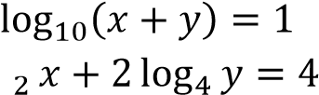
 . [(x, y) =(2,8)or (8,2)
- (a) If 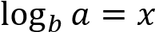, show that b = 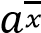 and deduce that 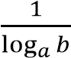.
(b) Solve
(i)
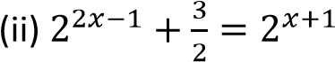[x=0 or 1.585]
11. Prove that 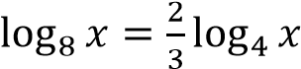. Hence without using tables or calculator, evaluate 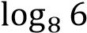 correct to three significant figure, if
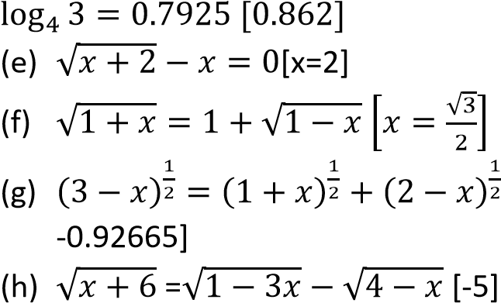[x =

- Without using mathematical tables or 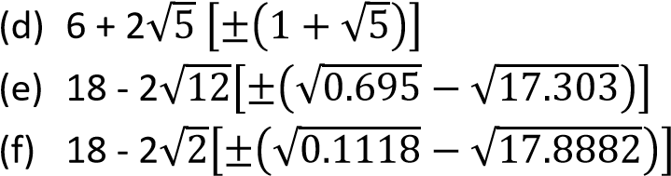calculators, find the value of
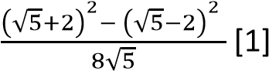
- Find the square root of the following

TOPIC 2/4: Series
Series

Introductions
Numbers arranged in a definite order a sequence. Each number in the sequence is derived from a particular rule.
The terms below are examples of sequences
- 1, 3, 5, 7, 9 ….. is a sequence of odd numbers
- 2, 3, 5, 7, 11 … is a sequence of prime number
- 4, 16, 64 …. is a sequence formed by multiplying the proceeding number by 4 to give the next number
Series are categorized into two:
- Arithmetic progression (A.P) - Geometric progression

Arithmetic progression (A.P)
This is a series in which each term is obtained from the preceding one by addition or subtraction of a constant quantity.
The series 1 + 3 + 5 + 7 + 9 ….. is an A.P
Note the following in an A.P
- The first term of an A.P is denoted a. the first letter of the English alphabet
- There is a common difference d. in the progression, a = 1 and d = 2.
- Given the first term, a and the common difference, d 1st term = a
2nd term = a + d 3rd term = a + 2d n^{th} term (U_{n}) = a + (n – 1)d
- The sum (S_{n}) of the first n terms of an A.P is given by,

S _{n} 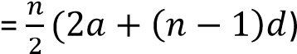
Or
S_{n} 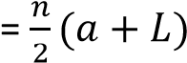 where L is the last term.
Example 1
Find the 30th term of a series that has an n^{th} term given by 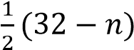
Solution
U_{n} 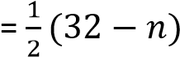
U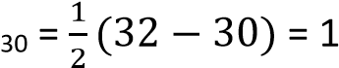
Example 2
The first term of an arithmetic progression (A.P) is 73 and the 9th term is 25. Determine the common difference Solution
U_{n} = a + (n – 1)d
25 = 73 + (9 – 1)d 25 = 73 + 8d d = -6
Example 3
The 3rd, 5th and 8th terms of A.P are 3n + 8, n + 34, and n³ + 15 respectively. Find the value of n and hence the common difference of the A.P Solution a + 2d = 3n + 8 ……………… (i) a + 4d = n + 24 ………………(ii) a + 7d = n³ + 15 …………….(iii)
Eqn. (ii) – eqn. (i) 2d = -2n + 16 d = -n + 8…………………… (iv)
eqn. (iii) – eqn. (i)
5d = n³ – 3n + 7 ………………… (v)
Substituting eqn. (iv) into eqn. (v)5t1 a = 2
Substitute for a in (v) 36 + b = 33 b = -3
Substituting for a and b in eqn. (i)
3 x 2 – 3 + c = 4 c = 1
Hence a = 2, b = -3 and c = 1
Example 4

The ninth term of an Arithmetic Progression (A.P) is greater than the fifth term by 6. The sum of the first twelve terms is 123. Find the

(a) common difference of the A.P Solution n^{th} term = a+ (n-1)d 9th term = a + 8d

5th term = a + 4d

=> a + 8d = a + 4d + 6

4d = 6 d = 1.5

(b) first term of the A.P.
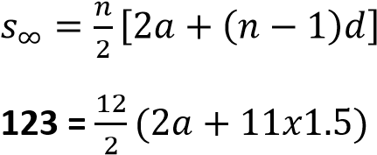

6(2a + 16.5) = 123

12a =24

a = 2
Example 5

The sum of the first 16 terms of an arithmetic progression (A. P) is 1088. The 16th term is twice the 8th term. Determine the value of the first term of the A.P. (05marks)

Solution

Let

The first term = a

And common difference = d

n^{th} term in A.P = a + (n – 1)d 8th term = a + 7d
16th term = a + 15d
But 2(a + 7d) = a + 15d
2a + 14d = a + 15d
- a = d
Sum (S_{n}) of the first n terms is given by
S_{n} 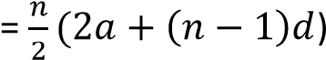
- 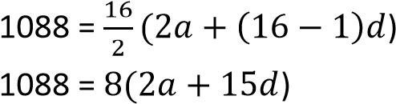
But a = d
- 1088 = 8 x 17a a = 8
Hence the first term is 8
Example 6
The first term of A.P is 73 and the common difference is -6, find the number of terms that must be added to give a sum of 96
Solution
S_{n} 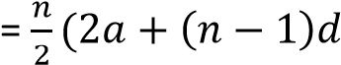
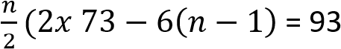
n(73 – 3(n – 1)) = 96 73n – 3n² + 3n = 96
3n² – 76n + 96 = 0
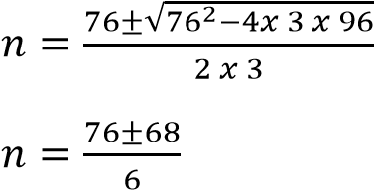
n = 24
Hence the number of terms that must be added to give a sum of 96 are 24
Example 7
The tenth term of an arithmetic progression (A.P) is 29 and the fifteenth term is 44. Find the value of the first term and the common difference. Hence find the sum of the first 30 terms
Solution
U _{n} = a + (n – 1)d U₁₀ = a + (10 – 1)d
a + 9d = 29 …………….(i) U₁₅ = a + (15 – 1)d a + 14d = 44 ………… (ii)
Eqn (ii) – eqn. (i) 5d = 15 d = 3
Substituting d in eqn. (i0 a + 9 x 2 = 29 a = 2
Sum of the first 30 terms
S_{n} 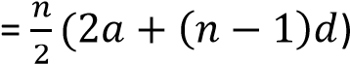
S _{n} 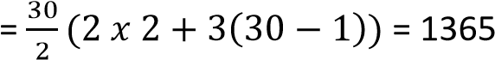
Example 8
The 5th term of an arithmetic progression (A.P) is 12 and the sum of the first 5 terms is 80. Determine the first term and common difference.
Solution
U_{n} = a + (n – 1)d [ Un= nth term, a = first term and d = common difference} U₅ = a + (5 – 1)d
a + 4d = 12 …………………………….(i)
The sum of the first n terms,
S_{n} 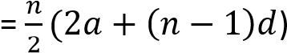
S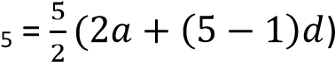
10a + 20d = 80 x 2 = 160 ………(ii)
Eqn. (ii) – 5eqn. (i) 5a = 100 a = 20
Substituting for a in eqn. (i) 20 + 4d = 12 d = -2
Hence the first term = 20 and the common difference = -2
Example 9
(a) Prove that 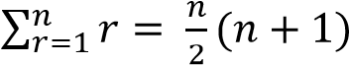
Solution
S_{n} = 1 + 2 + 3 + ….. + n
+ S_{n} = n + (n – 1) + (n – 2)+ …. + 1

2S_{n} = (n+1) + (n+1) + (n+1) + …. + (n+ 1)
2S_{n} = n(n + 1)
Sn = 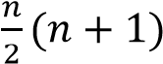
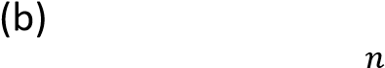Use your answer in (a) to deduce 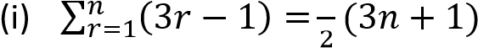
Note to deduce is to use the already existing result to work out other problems
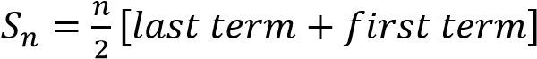
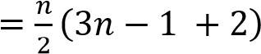
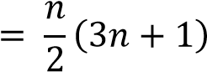
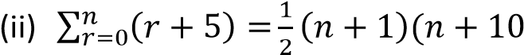
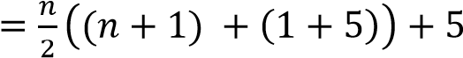
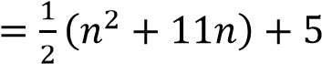
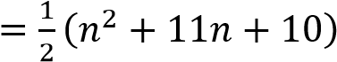
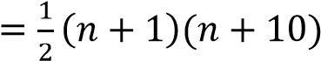

Inserting geometric means
Like for A.Ps, the terms inserted between given two values of a G.P are known as geometric means.
If n terms are inserted, then the total number of terms will be n+ 2 with the two extreme values representing the first and last terms respectively
Example 10
- Insert two geometric means between 2 and
16
Solution
1st term a = 2
4th term, ar³ = 16
2(r³) = 18
r = 2
the second term, ar = 2 x 2 = 4 the third term, ar² = 2 x 2² = 8
- Insert three geometric means between 1 and 81 a = 1
the 5th term ar⁴ = 81
1(r⁴) = 81 r = 3
the second term, ar = 1 x 3 = 3 the third term, ar² = 1 x 3² = 9 the third term, ar³ = 1 x 3³ = 27

Revision exercise 1
- Find the 5th and 8th terms of a series that has an nth term given by (-1)^{n}(2n + 1)
[-11, 17]
- The first term of an arithmetic progression (A.P) is . The sixth term of th A.P is four times the fourth term. Find the common difference of the A.P 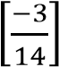
- The sum of p terms of an arithmetic progression is q and the sum of q terms is p; find the sum of p + q terms
- (a) The first four terms of an A.P are 5, 11, 17 and 23. Find the 30th term and the sum of the first 30 terms [179, 2760] (b) the second term of an A.P is 7 and the 7th term is -8. Find the first term, common difference and the sum of the first 14 terms
[10, -3, -133]
- (a) An A.P has the first term of 2 and common difference 5. Given that the sum of the first n terms of the progression is
119, calculate n [7]
  - the sum of the first five terms of an A.P is 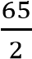. Also, five times the 7th term is the same as six times the second term. Find the first term and the common difference
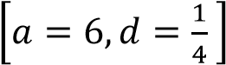
- The sum of the first n terms of the a series is n(n + 2). Find the first three terms. [3, 5,
7]
- In an A.P, the 1st term is 13 and 15th term is 11. Find the common difference and sum of the first 20 terms [7, 1590]
- (a) Show that In2^{r}, r = 1, 2,3, is an arithmetic progression
  - find the sum of the first 10 terms of the progression [38.1231]
  - Determine the least value of m for which the sum of the first 2m terms exceeds 883.7 [25]
- In an arithmetic progression u₁ + u₂ + u₃ + u₄
= 15 and u₁₆ = -3. Find the greatest integer
N such that U_{N} ≥ 0. Determine the sum of the first N terms of the progression. [ N =
14, S₁₄ = 136.5]

Geometric progression (G.P)
It is a series in which each term is obtained from the preceding one by multiplication or division by a constant quantity.
Observations
- The first term of G.P is also denoted, a
- The common ratio is r
- Given a and r 1st term = a
2nd term = ar
3rd term = ar² 4th term = ar³ nth term = ar^{n-1}

The sum (S_{n}) of the first n terms of G.P
The sum (S _{n}) of the first n terms of G.P is given by
S_{n} 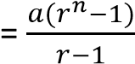 for r > 1 or
S_{n} 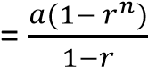 for r< 1

Sum to infinity of a G.P
We have seen that the sum of n terms of a G.P
for r < 1 is 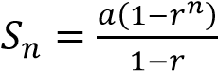
Now for -1 < n < 1 i.e. 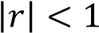, as n →, r^{n} →0
Therefore 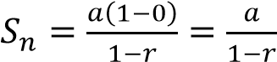
Hence the sum of a GP to infinity for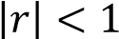 converges to 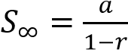 and diverges for r > 1 and r < 1

The geometric mean (G.M)
Suppose three numbers a, b and c are consecutive terms of GP, then, the middle term is the geometric mean.
The common ratio, r = 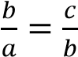
⇨ b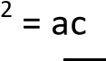
b = 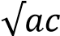, the geometric mean
Example 11

The sum to infinity of a Geometric Progression

(GP) is and the first term is 5. Find the

(a) common ratio of the GP. (03marks)
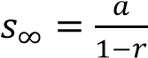
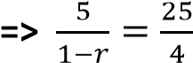

25(1-r) = 20

25r = 5

r = 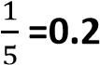

(b) sum of the first ten terms of the GP.

(02marks)
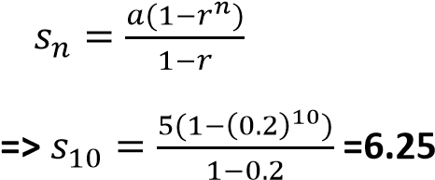

Example 12

Find the sum of the first ten terms of the geometric progression (G.P); 8 + 4 + 2 + ………
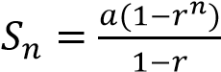

a = 8, r = 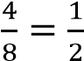, n = 10
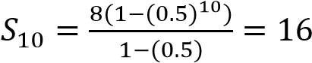
Example 13
A GP has 3rd term 7 and 5th term 847. Find the possible values of the common ratio and the corresponding 4th terms
Solution
U ₃ = ar² = 7
- ar² = 7 ………………..(i) U₅ = ar⁴ = 847
- ar⁴ = 847 ……………(ii)
Eqn. (ii) eqn. (i) r² = 121 r = 11 From eqn (i)
a = 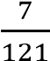
The 4th term, U₄ = ar³
If r = 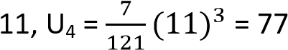
If r = -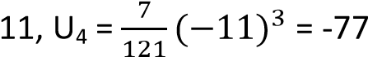
Example 14
In a G.P the 2nd term is 15 and the 5th term is 405. Find the sum of the first 8 terms

Solution
U ₂ = ar = 15
- ar = 15 ……………………..(i)
U₅ = ar⁴ = -405
- ar⁴ = -405 Eqn. (ii) eqn. (i) r³ =-27 r = -3
From eqn. (i), a = -5
Since r < 1
S_{n} 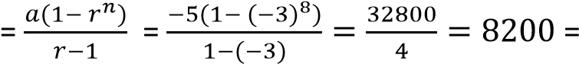 Example 15
In the geometric series u₁ + u₂ + u₃ + … u₁+ u₃ = 26 and u₃ + u₅ = 650.
Find the possible values of u₄ Solution u₁+ u₃ = 26 a + ar² = 26 a(1 + r²) = 26 ………………… (i) u₃ + u₅ = 650. ar² + ar⁴ = 650 ar²(1 + r²) = 650 ……………(ii) Eqn. (ii) eqn. (i) r² = 25
r = 5
From eqn. (i) a(1 + 25) = 26 a = 1 u₄ = ar³
If r = 5; u₄ = a(5)³ = 125
If r = 5; u₄ = a(-5)³ = -125
Example 16
In a Geometric Progression (G.P), the difference between the fifth and the second term is 156. The difference between the seventh and the fourth is 1404 Find the possible values of the common ratio.
U₅ – U₂ = 156 ar⁴ – ar = 156 ar(r³ -1) = 156 ……………. (i)
U₇ – U₄ = 156 Ar⁶ – ar³ = 1404 ar³(r³ -1) = 156 ……………. (ii) Eqn. (ii) eqn. (i)
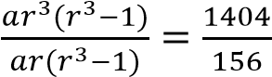
r² = 9 r =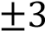
r = 3 and r = -3
Example 17
(a) The first three terms of a Geometric progression (G.P) are 4, 8 and 16. Determine the sum of the first ten terms of the G.P.
(04marks) solution
a = 4, ar = 6 4r = 8 r = 2
S_{n} 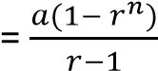
S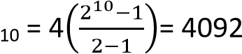
(b) An Arithmetic Progression (A.P) has a common difference of 3. A Geometric Progression (G.P) has a common ration of 2. A sequence is formed by subtracting the term of the A.P from the corresponding terms of the G.P. The third term of the sequence is 4. The sixth term of the sequence is 79. Find the first term of the
- A.P (08 marks)
- G.P (06 mars)
A.P
x, x+3, x +6, x + 9, x + 12, x+ 15, …… G.P y, 2y, 4y, 8y, 16y, 32y, …. 4y – (x + 6) = 4
4y – x = 10 ……………..(i) 32y – (x + 15) = 79
32y – x = 94………….. (ii)
Eqn. (ii) – Eqn. (i)
28y = 84, => y = 3
Substituting for y into eqn. (i)
12 – x = 10
x =2 (i) A.P, U₁ = 2 (ii) G.P, U₁ =3
Example 18
The sum of the first n terms of a geometric progression (G.P) is 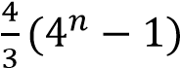. Find the n^{th} term as an integral power of 2
Solution
S_{n} 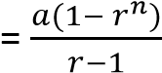
Comparing with S_{n} 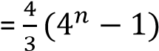
a = 4 r – 1 = 3, r = 4
The n^{th} term, U_{n} = ar^{n – 1}
= 4 x 4n-1 = 22 x 22(n-1) = 22+2n-2 = 22n
Example 19
Find three numbers in geometrical progression such that their9 sum is 26 and their product is 216
Solution
Let the numbers be , a and ar
Product = 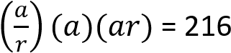
a³ = 216 = 6³ a = 6
the terms are 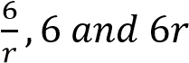
Sum of terms 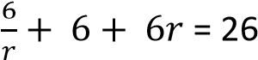
⇨ 6r² – 26r + 6 = 0 3r² – 13r + 3 = 0
(r – 3)(3r – 1) = 0
Either r – 3 = 0; r = 3
Or 3r - 1 = 0; r =
When r = 3
the terms are 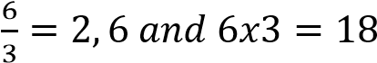
when r =
the terms are 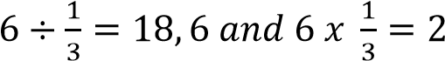
Hence the terms in their order are 2, 6, 18 or 18, 6, 2

Inserting geometric means
Like for A.Ps, the terms inserted between given two values of a G.P are known as geometric means.
If n terms are inserted, then the total number of terms will be n+ 2 with the two extreme values representing the first and last terms respectively
Example 20
- Insert two geometric means between 2 and
16
Solution
1st term a = 2
4th term, ar³ = 16
2(r³) = 18
r = 2
the second term, ar = 2 x 2 = 4 the third term, ar² = 2 x 2² = 8
- Insert three geometric means between 1 and 81 a = 1
the 5th term ar⁴ = 81
1(r⁴) = 81 r = 3
the second term, ar = 1 x 3 = 3 the third term, ar² = 1 x 3² = 9 the third term, ar³ = 1 x 3³ = 27

Mixed terms of A.P and G.P
These are problems involving both A.Ps and G.Ps. when handling we make use of their respective properties.
Example 21
A geometric progression (G.P) and an arithmetic progression (A.P) have the same first term. The sum of their first, second and third terms are 6, 10.5 and 18 respectively. Calculate the sum of their 5th terms.

Solution
Terms | G.P | A.P | Sum
1st | a | a | 2a = 6 …………………(i)
2nd | a + d | ar | a + d + ar = 10.5 ….(ii)
3rd | a + 2d | ar² | a + 2d + ar² = 18 ..(iii)
From eqn. (i): 2a = 6; a = 3
From eqn. (ii): 3 + d + 3r = 10.5 d + 3r = 7.5 ……………….. (iv) From eqn. (iii) 3 + 2d + 3r² = 18
2d + 3r² = 15 ……………..(v)
Eqn. (v) – 2eqn. (iv)
3r² – 6r = 0 3r(r -2) = 0 r -2 = 0 r = 2
Substitute for r into eqn. (iv) d + 6 = 7.5 d = 1.5
Sum of their fifth terms
= (a + 4d) + ar⁴
= (3 + 4 x 1.5) + 3 x 2⁴ = 57
Example 22
The 1st, 4thand 8th terms of A.P form a G.P. if the first term is 9, find the
- Common difference of the A.P
- Common ratio of the G.P
- Difference in sums of the first 6 terms of the progressions.

Solution
Given that a, a + 3d, a + 7d form a G.P
Substituting for a = 9, the terms are
9, 9 + 3d, 9 + 7d
For a G.P, r = 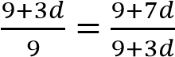
⇨ (9 + 3d)2 = 9(9 + 7d)
81 + 54d + 9d² = 81 + 63d
9d² – 9d = 0
9d(d – 1) = 0
Either d – 1 = 0; d = 1 Or d = 0
When d = 0 all terms of A.P are equal
Hence the common difference d = 1
Example 23
(a) The sum of the first m terms of a progression is m(2m + 11) (i) Show that the progression is an A.P
(ii) Determine the nth term of the progression

Solution
Given S_{m} = m(2m + 11)
First term = S₁ = 1(2 x 1 + 11) = 13
S₂ = 2(2 x 2 + 11) = 30
Second term = 30 – 13 = 17
S ₃ = 3(2 x 3 + 11) = 51
Third term = 51 – 20 = 21
The progression is 13, 17, 21, ….. Hence A.P with the first term 13 and common difference, d= 4
(ii) U_{n} = S_{n} – S_{n-1}
= n(2n + 11) – (n – 1)(2(n -1) + 11)
= 9 + 4n
Example 24
- The first, second and last term of an A.P are a, b, c respectively. Prove that the sum of all
terms is 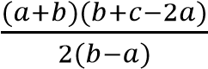
Solution
If the 1st term is a and the second term is b; the common difference, d = (b – a) Last term (nth terms c = a + (n – 1)d c = a + (n – 1)(b – 1)
i.e. n – 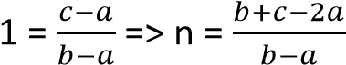 but S_{n} 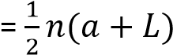
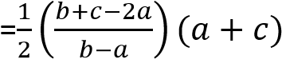
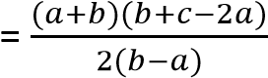

- The first, second and last terms of a GP are a and b. show that the sum of the first n terms is 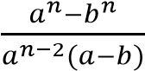
Solution
Common ratio =
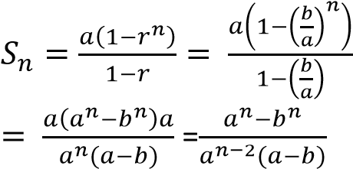
Example 25
- Calculate the sum to infinity of the following terms
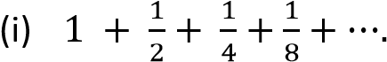
Solution a = 1 and r =
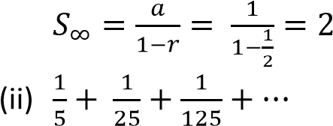
Solution a = and r =
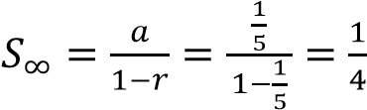
- Work out the following
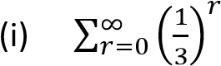
Solution
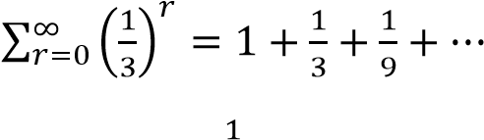
a = 1 and r =
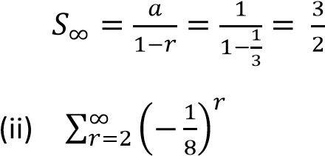
Solution
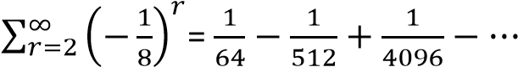
A =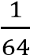 and r =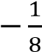
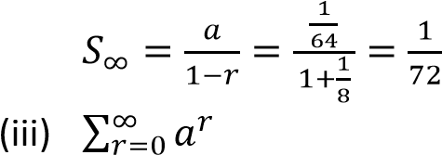
Solution a = 1 and r = a
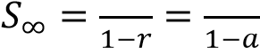

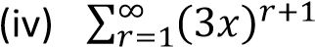
Solution
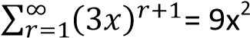+ 27x³ + 81x⁴ + …
a = 9x² and r = 3x
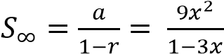

Example 26
- Express the following as fractions using approach of sum of a G.P to infinity
(i) 0. ̇
Solution
0.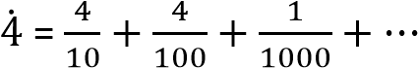
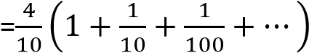
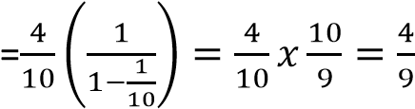

(ii) 3.1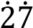
Solution
3.1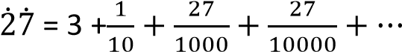
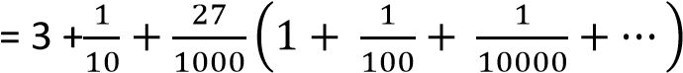
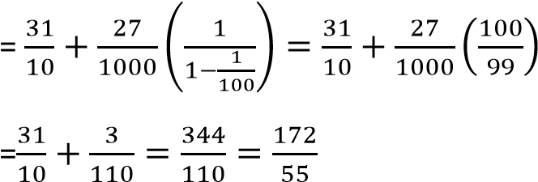
Hence 3.1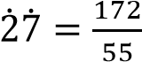
- The sum to infinity of a GP is 7 and the sum of the first two terms is 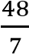. Find the common ratio and the first term of the GP with positive common ratio
Solution
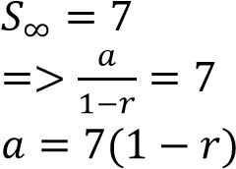 …………………….(i)
But S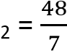 a + ar =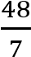 a(1 + r) = 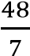 ……………………….(ii)
substituting eqn. (i) into eqn. (ii)
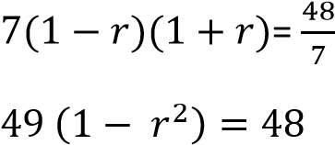
49r² = 1
r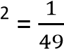
r = 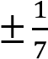
Considering appositive ratio From eqn. (i)
a = 7(1 -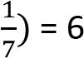

Revision exercise 2
- The common ration of a GP is -5 and the sum of the first seven terms of the progression is 449. Find the first three terms. 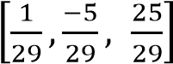
- In the geometrical series 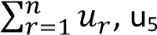 – u₂ =
156 and u₇ – u₄ = 1404. Find the possible values of the common ratio and
corresponding values of u₁ [
r = 3, a = 156; r = -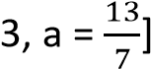
- The sum of the second and third terms of a G.P is 9. It the seventh term is eight times the fourth term, find the
(a) The first term and the common ration
[a =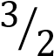 and r = 2]
(b) The sum of the fourth and first term
[36]
- Find the sum of ten terms of geometrical series 2, -4, 8 ….. *-682]
- The second and the third terms of a G.P progression are 24 and 12(b + 1) respectively. Find b if the sum of the first three terms of the progression is 76
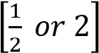
- The sum of the 2nd and 3rd terms of a G.P is 12. The sum of the 3rd and 4th terms is -36.
Find the 1st term and common ratio [a = 2, r
= -3]
- What is the smallest number of terms of GP 5, 10, 20 …. that can give a sum greater than 500, 000 [n= 17]
- The first, fourth and eighth terms of Arithmetic progression (A.P) form a geometric progression. If the first term is 9, find
    - The common difference of A.P [ 1]
    - The common ratio of the G.P 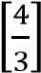
    - The difference in the sums of the first 6 terms of the progressions [55.7049]
- The second, third and ninth terms of an A.P form a G.P. find the common ratio of the
G.P [6]
- (a) The sum of the first 10 terms of an AP is 120. The sum of the next 8 terms is 240.
Find the sum of the next 6 terms [264] (b) the arithmetic mean of the a and b is three times their geometric mean. Show
that

√

- The first three terms of a geometric series are 1, p, and q. Given also that 10, q and p are the first three terms of an arithmetic series. Show that 2p² – p – 10 = 0
Hence find the possible values of p and q [p
= -2 and q = 4 or p = and q =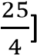
Application of A.Ps and G.Ps to interest rates
If a sum of money P is invested at a simple interest rate of r% per annum, the amount received after n years is given by A = P + I
where I = 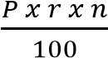
By substitution we have
A = P + 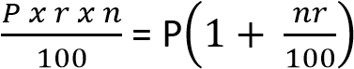
The interest for one year is 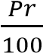, for 2 years is
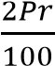, for n year = 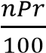. Therefore the various amounts of interest after one, two, three, etc. years form an AP
On the other hand, if the principal P is invested at compound interest rate of r% per annum, the interest being added annually, the amount after one year is 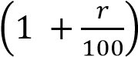 , after two years is
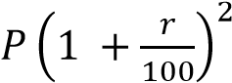, after 3 years is
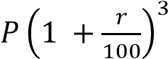 and after n years 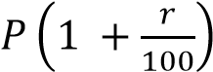
Hence the amounts after one, two, three, etc. years for a GP.
Note: if with compound interest is added half annually as much as when added yearly, but it is added twice as much. Hence amount A =
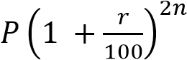
Now suppose that instead of adding the interest annually, it is the principal, P which is added annually,
Amount after 1st year = 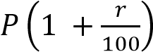
Amount after 2nd year = 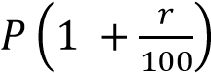
Amount after 3rd year = 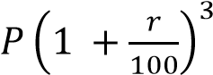
Amount after n^{th} year = 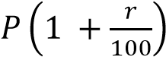
Total amount after n years
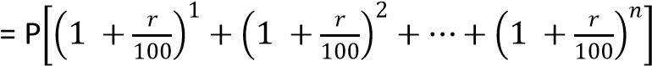
This is a G.P with:
first term = 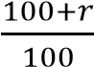= (100 + r)%
And common ratio 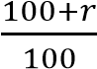= (100 + r)%
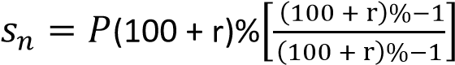
Example 23
(a) Find the amount at the end of ten years when 500000 shillings is invested at 5% compound interest (i) the interest being added annually Solution
A = 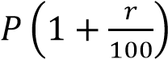
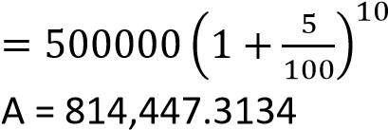
(ii) the interest being added twice a year Solution
A = 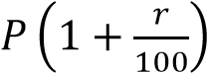
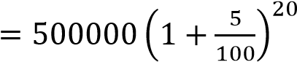
A = 1,326,648.853

(b) Find the amount at the end of ten years when 500000 shillings is invested at 5% simple interest
A = 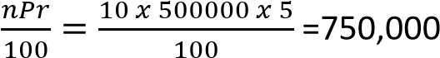
1. John opened an account in the bank and deposited200,000 shillings every month for ten months without withdrawing. Find how much money he accumulated after 10 months if the bank offered 10% compound interest per month. [3,506,233.412]
Peter deposited sh. 100,000 at the beginning of
every year for 5 years; find

1st | 2nd | 3rd | 4th
4 | 3 | 2 | 1
TOPIC 3/4: Permutations and Combinations
Permutations and combinations

Permutation
A permutation is an ordered arrangement of a number of objects
Consider digits 1, 2 and 3; find the possible arrangements of the digits

123, 132, 321
The total of six

231, 321, 321
This problem may also be solved as follows:
Given the three digits above, the first position can take up three digits, the second position can take up two digits and the third position can take up 1 digit only
1st position | 2nd position | 3rd position
3 | 2 | 1
The total is thus 3 x 2 x 1 = 6
If the digits were four say 1, 2, 3, 4 the arrangement would be

The total is thus 4 x 3 x 2 x 1 = 24
In summary the number of ways of arranging n different items in a row is given by n(n – 1)(n – 2)(n -3) x ……….2 x 1 and can be expressed as n!
If the total number of books is 6
The total number of arrangements = 6!
= 6 x 5 x 4 x 3 x 2 x 1 = 720 ways
Example 1
Find the values of the following expression
(a) 5!
Solution
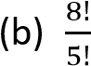5!= 5 x 4 x 3 x 2 x 1 = 120
Solution
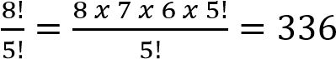

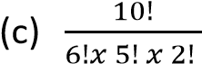
Solution
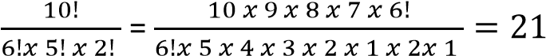

(d) Four different pens and 5 different books are to be arranged on a row. Find
- The number of possible arrangements of items Solution
Total number of items = 4 + 5 = 9 Total number of arrangements = 9!
= 9 x 8 x 7 x 6 x 5 x 4 x 3 x 2 x 1
= 362,880 ways
- The number of possible arrangements if the pens must be kept together
Solution
The pen is taken to be one since they are to be kept together. So we consider total number of items to six. The number of
arrangements of six items = 6! = 6 x 5 x 4
x 3 x 2 x 1
= 720 ways
The arrangement of 4 pens = 4!
= 4 x 3 x 2 x 1 =24 Total number arrangements of all the items = 720 x 24 = 17, 280
Example 2
- How many arrangements can be made using the letters in the word “TROTTING”?
Solution
TROTTING has 8 letters and 3T’2
Number of arrangements = 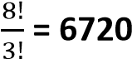
- In how many of these arrangements are the letters N and G next to each other.
Solution
Since N and G are always together, they are counted as one letter
=> TROTTING has 7 letters and 3T’2 Number of arrangements = 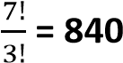
Number of arrangements of N and G = 2! =2
Total number of arrangements = 840 x 2 = 1680
Multiplication principle of permutation
If one operation can be performed independently in a different ways and the second in b different ways, then either of the two events can be performed in (a + b) ways
Example 3
There are 6 roads joining P to Q and 3 roads joining Q to R. Find how many possible routes are from P to R
From P to Q = 6 ways
From Q to R = 3 ways
Number of routes from P to R = 6 x 3 = 18
Example 4
Peter can eat either matooke, rice or posh on any of the seven days of the week. In how many ways can he arrange his meals in a week?
Solution
For each of the 7 days, there are 3 choices
Total number of arrangements
= 3 x 3 x 3 x 3 x 3 x 3 x 3 = 3⁷ = 2187 ways
Example 5
There are four routes from Nairobi to Mombasa. In how many different ways can a taxi go from Nairobi to Mombasa and returning if for returning?
- any of the route is taken
= 4 x 4 = 16 ways
- the same route is taken
= 4 x 1 = 4 ways
- the same route is not taken
= 4 x 3 = 12 ways
Example 6
David can arrange a set of items in 5 ways and John can arrange the same set of items in 3 ways. In how many ways can either David or John arrange the items?
Solution
Number of ways in which David arranges = 5
Number of ways in which John arranges = 3
Number of ways in which either David or John arrange the items = 5 + 3 = 8 ways
The number of permutation of r objects taken from n unlike objects
The permutation of n unlike objects taking r at a time is denoted by ^{n}P_{r} which is defined as n 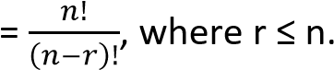
P_{r}
In case r = n, we have ^{n}P_{n} which is interpreted as the number of arranging n chosen objects from n objects denoted by n!
n 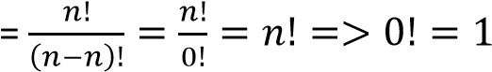
P_{n}
Example 7
How many three letter words can be formed from the sample space {a, b, c, d, e, f}
Solution
Total number of letters = 6 and r = 3
Total number of worms = ⁶P₃
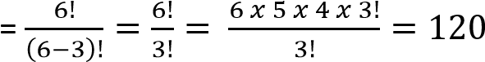ways

Example 8
Three letters are chosen at random from the word CLOTHINGS. Determine the probability that two of the three letters chosen are consonants. (05markks)
Solution
Total number of letters in CLOTHINGS = 9 letters
Selection of 3 teachers from 9 letters ⁹C₃ = 84
Possible selection
7 consonants | 2 Vowels
2 | 1
Number of selections = ⁷C₂.² C₁
= 21 x 2
= 42
Probability = 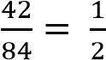
Example 9
Find the possible number of ways of arranging 3 letters from the word MANGOES
Solution
Total number of letter in the word = 7
and r = 3
Number of ways 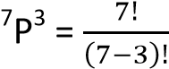
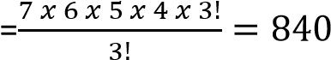ways
Example 10
Find number of ways of arranging six boys from a group of 13
Solution
Number of arrangements = ¹³P₆
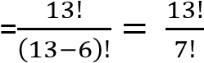
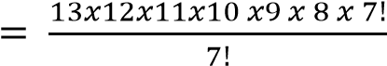
= 1235520 ways
The number of permutations of n objects of which r are alike
The number of permutations of n objects of which r are alike is given by 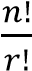
Example 11
Find the number of arranging in a line the letters B, C, C, C, C, C, C
The number of ways of arranging the seven
letters of which of which 6 are alike 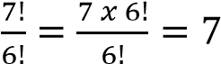 ways
The number of ways of permutations on n objects of which p of one type are alike, q of the second type are alike, r of the third type are alike, and so on.
The number of ways of permutations on n objects of which p of one type are alike, q of the second type are alike, r of the third type are
alike given by 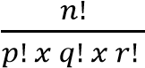
Example 12
Find the possible number of ways of arranging the letter of the word MATHEMATICS in line
Solution
The word MATHEMATICS has 11 letters and contains 2 M, 2A and 2T repeated
The number of ways = 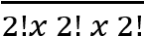
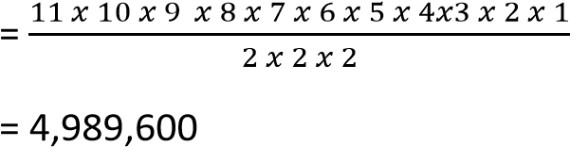
Example 13
Find the possible number of ways of arranging the letter of the word ‘MISSISSIPPI’ in line Solution
The word ‘MISSISSIPPI’ has 10 letters with 4I, 4S, and 2P
The number of ways = 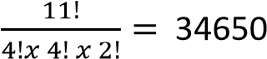
The number of permutations of the like and unlike objects with restrictions
One should be cautious when handling these problems
Example 14
Find the possible number of ways of arranging
The letters of the word MINIMUM if the arrangement begins with MMM?
Solution
There is only one way of arranging MMM
The remaining contain four letters with 2I can be arranged in
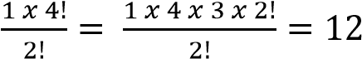 ways
Example 15
- How many 4 digit number greater than 6000 can be formed from 4, 5, 6, 7, 8 and 9 if:
  - Repetitions are allowed
Solution
The first digit can be chosen from 6, 7, 8 and 9, hence 4 possible ways, the 2nd, 3rd and 4th are chosen from any of the six digits since repetitions are allowed
position | 1st | 2nd | 3rd | 4th
selections | 4 | 6 | 6 | 6
Number of ways
= 4 x 6 x 6 x 6 = 864 ways

  - Repetition are not allowed The first can be chosen from 6, 7, 8 and
9, hence 4 possible ways, the 2nd from
5, 3rd from 4 and 4th from 3 since no repetitions are allowed
position | 1st | 2nd | 3rd | 4th
selections | 4 | 5 | 4 | 3
Number of ways
= 4 x 5 x 4 x 3 = 240 ways

- Find how many four digit numbers can be formed from the six digits 2, 3, 5, 7, 8 and 9 without repeating any digit.
Find also how many of these numbers
  - Are less than 7000 (ii) Are odd
Solution
position | 1st | 2nd | 3rd | 4th
selections | 6 | 5 | 4 | 3
Total number of ways = 6 x 5 x 4 x 3 = 360
(i) The 1st number is selected from three (2,
3, 5), the 2nd number from 5, the 3rd from
4 and the 4th from 3 digits
position | 1st | 2nd | 3rd | 4th
selections | 6 | 5 | 4 | 3
Total number of less than 7000
= 3 x 5 x 4 x 3 = 180
  - The last number is selected from four odd digits (3, 5, 7, and 9), the 1st number selected from five remaining, 2nd from 4 and 3rd from 3
position | 1st | 2nd | 3rd | 4th
selections | 5 | 4 | 3 | 4
Total number of odd numbers formed
= 5 x 4 x 3 x 4 = 240
- How many different 6 digit number greater than 500000 can be formed by using the
digits 1, 5, 7, 7, 7, 8
Solution
The 1st digit is selected from five (5, 7, 7, 7, 8), the 2nd from remaining five, 3rd from four, 4th from three, 5th from two and 6th from one
1st | 2nd | 3rd | 4th | 5th | 6th
5 | 5 | 4 | 3 | 2 | 1

Total number = 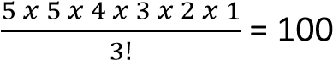
NB. The number is divided by 3! Because 7 appears three times
- How many odd numbers greater than 60000 can be formed from 0, 5, 6, 7, 8, 9, if no number contains any digit more than
once Solution
Considering six digits
Taking the first digit to be odd, the first digit is selected from 3 digits (5, 7, 9) and the last is selected from 2 digits
1st | 2nd | 3rd | 4th | 5th | 6th
3 | 4 | 3 | 2 | 1 | 2

Number of ways = 3 x 4 x 3 x 2 x 1 x 2
= 144
Taking the first digit to be even, the first digit is selected from 2 digits (6, 8) since the number should be greater than 60000 and the last is selected from 2 odd digits
1st | 2nd | 3rd | 4th | 5th | 6th
2 | 4 | 3 | 2 | 1 | 3

Number of ways = 3 x 4 x 3 x 2 x 1 x 2
= 144 Considering five digits Taking the first digit to be odd, the digit greater than 6 are 7 and 9 so first digit is selected from 2 digits and the last is selected from 2 digits
1st | 2nd | 3rd | 4th | 5th
2 | 4 | 3 | 2 | 2

Number of ways = 2 x 4 x 3 x 2 x 2
= 96
Taking the first digit to be even, the first digit is selected from 2 digits (6, 8) since the number should be greater than 60000 and the last is selected from 3 odd digits (5, 7, 9)
1st | 2nd | 3rd | 4th | 5th
2 | 4 | 3 | 2 | 3

Number of ways = 2 x 4 x 3 x 2 x 3
= 144
The total number of selections
= 144 + 144 + 96 + 144 = 528
Example 16
The six letter of the word LONDON are each written on a card and the six cards are shuffled and placed in a line. Find the number of possible arrangements if
- The middle two cards both have the letter N on them
Solution
If the middle letter are NN, the we need to find the number of different arrangements of the letter LODO. With the 2O’s, the number of arrangements = 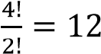

- The two cards with letter O are not adjacent and the two cards with letter N are also not adjacent
Solution
If the two cards are not adjacent, the number of arrangements = Total number of arrangements of the word LONDON – number of arrangements when the two letters are adjacent
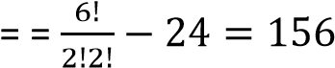
Example 17
In how many different ways can letters of the word MISCHIEVERS be arranged if the S’s cannot be together
Solution
There are 11 letters in the word MISCHIEVERS with 2S’s, 2I’s and 2E’s
Total number of arrangements
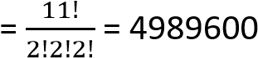
If S’s are together, we consider them as one, so the number of arrangements
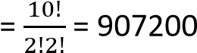
the number of possible arrangements of the
word MISCHIEVERS when S’s are not together = 4989600 – 907200 = 4082400
The number of permutation of n different objects taken r at a time, if repetition are permitted
Example 18
How many four digit numbers can be formed from the sample space {1, 2, 3, 4, 5} if repetitions are permissible
Solution
The 1st position has five possibilities, the 2nd five, the 3rd five, the 4th five
Number of permutations = 5 x 5 x 5 x 5 = 625

Circular permutations
Here objects are arrange in a circle
The number of ways of arranging n unlike objects in a ring when clockwise and anticlockwise are different.
Consider four people A, B, C and D seated at a round table. The possible arrangements are as shown below
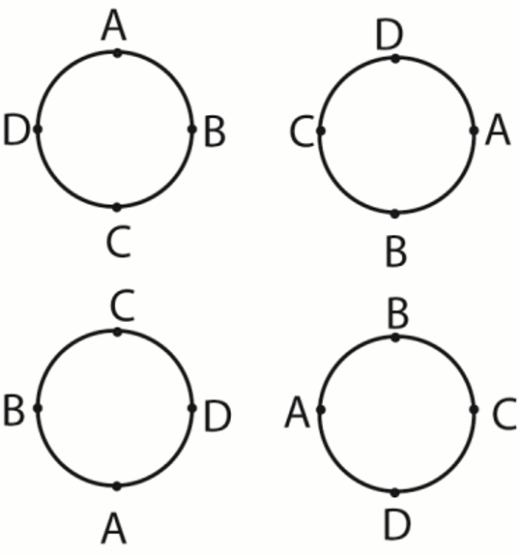
With circular arrangements of this type, it is the relative positions of the objects being arranged which is important. The arrangements of the people above is the same. However, if the people were seated in a line the arrangements would not be the same, i.e. A, B, C, D is not the same as D, A, B, C. When finding the number of different arrangements, we fix one person say A and find the number of ways of arranging B, C and D.
Therefore, the number of different arrangements of four people around the table is 3!
Hence the number of different arrangements of n people seated around a table is (n – 1)!
Example 19
- Seven people are to be seated around a table, in how many ways can this be done
Solution
The number of ways = (7 – 1)! = 6! = 720
- In how many ways can five people A, B, C, D and E be seated at a round table if (i) A must be seated next to B
Solution
If A and B are seated together, they are taken as bound together. So four people are considered
The number of ways = (4 – 1)! = 3! = 6
The number of ways in which A and B can be arranged = 2
The total number of arrangements
= 6 x 2 = 12 ways
(ii) A must not seat next to B
If A and B are not seated together, then the number of arrangements = total number of arrangements – number of arrangements when A and B are seated together
= (5 – 1)! – 12 = 12 ways
The number of ways of arranging n unlike objects in a ring when clockwise and anticlockwise arrangements are the same
Consider the four people above, if the arrangement is as shown below
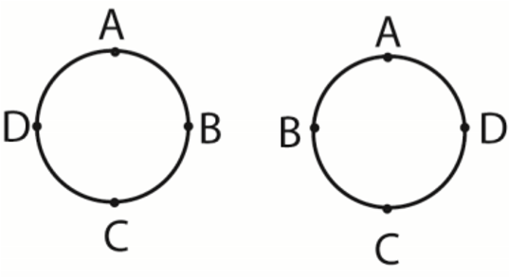
Then the above arrangements are the same since one is the other viewed from the opposite side
The number of arrangements = = 3ways
Hence the number of ways of arranging n unlike objects in a ring when clockwise and anticlockwise arrangements are the same =
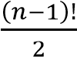
Example 20
A white, a blue, a red and two yellow cards at arranged on a circle. Find the number of arrangements if red and white cards are next to each other.
Solution
If red and white cards are next to each other, they are considered as bound together. So we have four cards. Since anticlockwise and clockwise arrangements are the same and there are two yellow cards, the number of
arrangements = 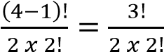
The number of ways of arranging red and white cards = 2
Total number of ways of arrangements
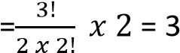
Revision exercise 1
- In how many ways can the letters of the words below be arranged (a) Bbosa (5!]
(b) Precious [8!]
- How many different arrangements of the letters of the word PARALLELOGRAM can be made with A’s separate *83160000+
- How many different arrangements of the letters of the word CONTACT can be made with vowels separated? [900]
- How many odd numbers greater than 6000 can be formed using digits 2, 3, 4, 5 and 6 if each digit is used only once in each number
[12]
- Three boys and five girls are to be seated on a bench such that the eldest girl and eldest boy sit next to each other. In how many ways can this be done [2 x 7!]
- A round table conference is to be held between delegates of 12 countries. In how many ways can they be seated if two
particular delegates wish to sit together [2 x 10!]
- In how many ways can 4 boys and 4 girls be seated at a circular table such that no two boys are adjacent [144]
- How many words beginning or ending with a consonant can be formed by using the letters of the word EQUATION? [4320]

Combinations
A combination is a selection of items from a group not basing on the order in which the items are selected
Consider the letters A, B, C, D
The possible arrangements of two letters chosen from the above letters are
AB, AC, AD, BA, BC, BD, CA, CB, CD, DA, DB, DC. AS seen earlier, the total number of arrangements of the above letters is expressed
as 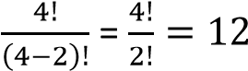
However, when considering combinations, the grouping such as AB and BA are said to be the same groupings such as CA and AC, AD and DA, etc.
So the possible combinations are AB, AC, AD, BC, BD, CD which is six ways.
Thus the number of possible combinations of n items taken r at a time is expressed as ^{n}C_{r} or
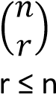which is defined as ^{n}C _{r} where
=

(

)

Hence the number of combinations of the above letters taken two at a time is
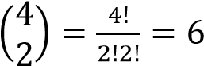

Example 21
Three letters are chosen at random from the word CLOTHINGS. Determine the probability that two of the three letters chosen are consonants.
Solution
Total number of letters in CLOTHINGS = 9 letters
Selection of 3 teachers from 9 letters ⁹C₃ = 84
Possible selection
7 consonants | 2 Vowels
2 | 1
Number of selections = ⁷C₂.²C₁
= 21 x 2
= 42
Probability =
Example 22
A committee of four people is chosen at
random from a set of seven men and three women
How many different groups can be chosen if there is at least one
- Woman on the committee Solution
Possible combinations
7 men | 3 women
3  2  1 | 1  2  3
The number of ways of choosing at least one woman
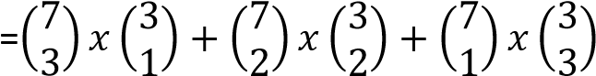
- Man on the committee
7 men | 3 women
1  2  3  4 | 3  2  1  0
The number of ways of choosing at least one man
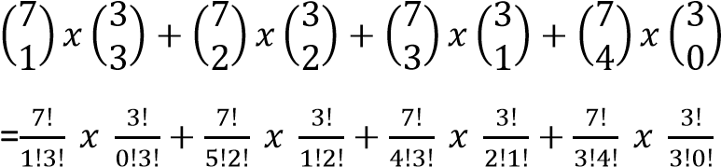
=210
Example 23
A group of nine has to be selected from ten men and eight women. It can consist of either five men and four women or four men and five women. How many different groups can be chosen?
Solution
Possible combination
10 men | 8 women
5  4 | 4  5
Number of groups = 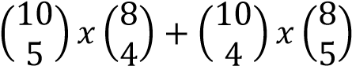
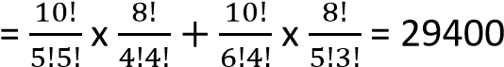
Example 24
13 boys | 7 girls
A team of six is to be formed from 13 boys and 7 girls. In how many ways can the team be selected if it must consist of (a) 4 boy and 2 girls
4 | 2

( ) ( )= = 15015

(b) At least one member of each sex
Possible combinations
13 boys | 7 girls
5  4  3  2  1 | 1  2  3  4  5

=( ) ( ) ( ) ( ) ( ) ( )

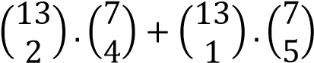
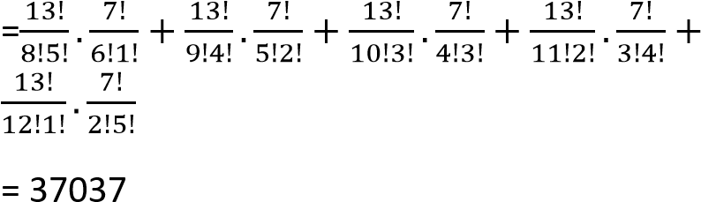
Example 25
A team of 11 players is to be chosen from a group of 15 players. Two of the 11 are to be randomly elected a captain and vice-captain respectively. In how many ways can this be done?
Number of ways of choosing 11 players from 15
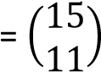
A captain will be elected from 11 players and a vice-captain from 10 players
Total number of selection =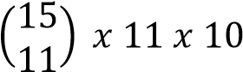
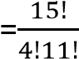 x 11 x 10 = 150150
Example 26
- Find the number of different selections of 4 letters that can be made from the word UNDERMATCH.
Solution
There are 10 letters which are all different Number of selections of 4 letters from 10 is
given by 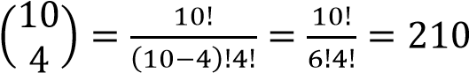
- How many selections do not contain a vowel?
Solution
Number of vowels in the word = 2
Number of letters not vowels = 8 Number of selections of 4 letters from 10 without containing a vowel = selecting 4 letters from 8 consonants =
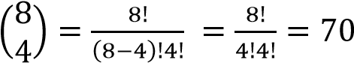
Example 27
In how many ways can three letters be selected at random from the word BIOLOGY is selection
- Does not contain the letter O
Solution
Number of selections without the letter O = number of ways of choosing three letters from B, I, L, G, y
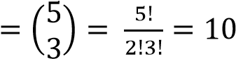
- Contain only the letter O
Solution
Number of selections with one letter O =
number of ways of choosing two letters from B, I, L, G, y
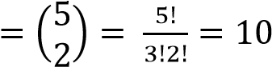
- Contains both of the letters O
Solution
Number of selections with two letter O =
number of ways of choosing one letter from
B, I, L, G, y
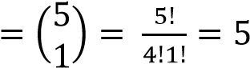

Example 28
In how many ways can four letters be selected at random from the word BREAKDOWN if the letters contain at least one vowel?
Solution
Vowels: E, A, O (3)
Consonants: B, R, K, D, W, N (6)
Consonants (6) | Vowels (3)
3  2  1 | 1  2  3
Number of selection of four letters with at least one vowel
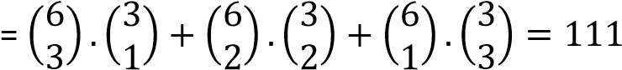
Example 26
How many different selections can be made from the six digits 1, 2, 3, 4, 5, 6
Solution
Note: this an open questions because selections can consist of only one digit, two digits, three digits, four digits, five digits or six digits Number of selection of 1 digit = ⁶C₁ = 6
Number of selection of 2 digits = ⁶C₂ = 15
Number of selection of 3 digits = ⁶C₃ = 20
Number of selection of 4 digits = ⁶C₄ = 15
Number of selection of 5 digits = ⁶C₅ = 6
Number of selection of 6 digits = ⁶C₁ = 1
Total number of selections
= 6 + 15 + 20 + 15 +6 + 1 = 63
This approach is tedious for a large group of objects.
The general formula for selection from n unlike objects is given by 2^{n} – 1.
For the above problems, number of selections = 2⁶ – 1 = 63
Example 29
How many different selections can be made from 26 different letters of the alphabet? Number of selection = 2²⁶ – 1
= 67,108,863

Cases involving repetitions
Suppose we need to find the number of possible selections of letters from a word containing repeated letters, we take the selections mutually exclusive
Example 30
How many different selections can be made from the letters of the word CANADIAN?
Solution
There are 3A’s, 2N’s and 3 other letters
The A’s can be dealt with in 4 ways (either no A, 1A’s, 2A’s or 3A’s)
The N’s can be dealt in 3 ways (no N, 1N, or 2N’s)
The C can be dealt with in 2 ways (no C, 1C)
The D can be dealt with in 2 ways (no D, 1D)
The I can be dealt with in 2 ways (no I, 1I)
The number of selections
= 4 x 3 x 2 x 2 x 2 – 1 = 95
Example 31
How many different selections can be made from the letters of the word POSSESS?
Solution
There are 4S’s and 3 other letters
The S’s can be dealt in 5 ways (no S, 1S, 2N’s, 3S’s, 4S’s, or 5S’s)
The P can be dealt with in 2 ways (no P, 1P)
The O can be dealt with in 2 ways (no O, 1O)
The E can be dealt with in 2 ways (no E, 1E)
Total number of selections = 5 x 2 x 2 x 2 – 1
= 39

Cases involving division into groups
The number of ways of dividing n unlike objects into say two groups of p and q where p + q = n is given by 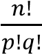
For three groups of p, q and r provided p + q + r = n
Number of ways of division = 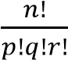
However, for the two groups above, if p = q then the number of ways of division = 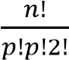 For three groups where p = q = r then the number of ways of division = 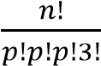
Example 32
The following letters a, b, c, d, e, f, g, h, I, j, k, l are to be divided into groups containing
- 3, 4, 5
- 5, 7
- 6, 6
- 4, 4, 4 letters. In how many ways can this be done?
Solution
- Number of ways = 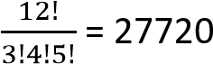
- Number of ways = 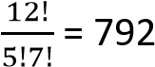
- Number of ways = 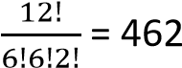
- Number of ways = 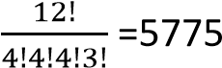
Example 33
Find the number of ways that 18 objects can be arranged into groups if there are to be
- Two groups of 9 objects each
- Three groups of 6 objects each
- 6 groups of 3 objects each
- Three groups of 5, 6 and 7 objects each
Solution
- Number of ways = 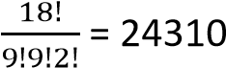
- Number of ways = 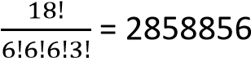
- Number of ways = 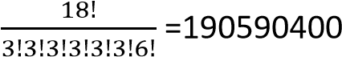
- Number of ways = 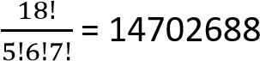
Example 34
- Find how many words can be formed using all letters in the word MINIMUM.
Solution
Number of ways of arranging the letters = 7!
There are 3M’s and 2I’s
Number of words formed = 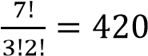
- Compute the sum of four-digit numbers formed with the four digits 2, 5, 3, 8 if each digit is used only once in each arrangement
Solution
Number of ways of arranging a four digit number = 4!
Sum of any four digit number formed = 2 + 5 + 3 + 8 = 18
Total sum of four digit numbers formed
= 18 x 4! = 432
- A committee consisting of 2 men and 3 women is to be formed from a group of 5

men and 7 women. Find the number of (b) How many arrangement can be made different committees that can be formed. If from the letters of the name
two of the women refuse to serve on the MISSISSIPPI
same committee, how many committees (i) when all the letters are taken at a
can be formed? time [34650]

Solution If the two letters PP begin every
( ii )
The committees formed = ⁵C₂.⁷C₃ word [630 ways]

= 10 x 35 = 350 (c) Find the number of ways in which a one
Suppose two women are to serve together, we can chose one or more of the four girls take them as glued together, so the number of to join a discussion group [15
committees =⁵C₂.⁶C₃ = 200 ways]
- Find in how many ways 11 people can be Number of committees in which two women divided into three groups containing 3, 4, 4 refuse to serve together = 350 – 200 = 150 people each. [5775]
- A group of 5 boys and 8 girls. In how many
ways can a team of four be chosen, if the
Revision exercise 2 team contains
(a) No girl [5]
1. (a) Find the number of different selection of ( b ) No more than one girl [85]
3 letters that can be made from the word ( c ) At least two boys [365]
PHOTOGRAPH. [53] 6. Calculate the number of 7 – letter
- How many of these selections contain arrangements which can be made with the
no vowel [18] letters of the word MAXIMUM. In how
- How many of these selections contain many of these do all the 4 consonants
at least one vowel? [35]
appear next to each other? [840, 96] 2. (a) find the number of different selections 7. In how many ways can a club of 5 be of 3 letters that can be made from the selected from 7 boys and 3 girls if it must
letters of the word SUCCESSFUL.[36]
contain
- How many of these selections contain ( a ) 3 boys and 3 girls [105] only consonants [11] ( b ) 2 men and 3 girls [21]
- How many of these selections contain ( c ) At least one girl [231] at least one vowel [25]^{n} ^{n} 8. How many different 6 digit numbers greater
3. (a) Find the value of n if P
₄ = 30 C₅ [8] than 400,000 can be formed form the
following digits 1, 4, 6, 6, 6 7? [100]

TOPIC 4/4: Time Series Analysis

Moving averages
Average = 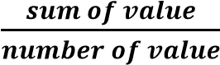
Moving averages are a series of averages of values
Order of moving averages is number of values required to form an average.
Calculation of moving averages
- Moving total is the sum of n values, the first moving average is written against the (n-1)^{th} value.
- First moving averages =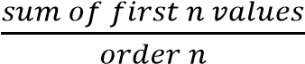
- Second moving averages =
- Third moving averages = .
- This process continues up to last value of the data

Example 1
The table below shows the enrollment of students in an institution over a period of 5 years.
Year | 2003 | 2004 | 2005 | 2006 | 2007
Number  of students | 145 | 182 | 170 | 155 | 213
Calculate
(a) three-year moving averages. (03marks)
Solution
- first three-year moving total = 145 + 185 + 170 = 497
- First three-year moving average = 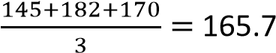
- Second three-year moving total =182+170+155 =507
- Second three-year moving averages = 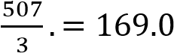
- Third three-year moving total =170+155+213 =538 - Third three-year moving averages = 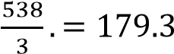
The values are filled in the table as shown below
Year | Tax | Moving  totals
2003 | 145
2004 | 182 | 497 | 165.7
2005 | 170 | 507 | 169.0
2006 | 155 | 538 | 179.3
2007 | 213
208 | x

(b) number of students enrolled in 2008, given that the fourth moving average is 203. (02 marks)
Let the number enrolled in 2008 be
Fourth three-year moving averages = 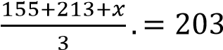
⇨ 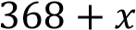 = 203 x 3

Example 2
The table below shows quarterly sales of cars for the year 2000, 2001 and 2002 by a company.
YEAR |  | QU | ARTER
YEAR | 1st | 2nd | 3rd | 4th
2000 | 390 | 310 | 280 | 355
2001 | 420 | 320 | 305 | 410
2002 | 400 | 350 | 315 | 425
- Calculate a four point moving average for the data. (06marks)
First four point moving total = 390+310+280+355 =1335
First four point moving average =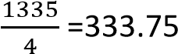
Second four point moving total = 310+280+355+420 =1365
Second four point moving average =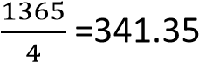
The calculations are carried on, the values filled into the table as shown below
Year | Quarter | Sales | Moving totals | Moving averages
2000 | 1 | 390
2000 | 2 | 310
2000 | 3 | 280 | 1335 | 333.75
2000 | 4 | 355 | 1365 | 341.35
2001 | 1 | 420 | 1375 | 343.75
2001 | 2 | 320 | 1400 | 350
2001 | 3 | 305 | 1455 | 363.75
2001 | 4 | 410 | 1495 | 373.75
2002 | 1 | 460 | 1525 | 381.25
2002 | 2 | 350 | 1535 | 383.75
2002 | 3 | 315 | 1550 | 387.3
2002 | 4 | 425
2003 | 1 | x

- (i) Plot a four – point moving average for the data on the same axes. (06marks)
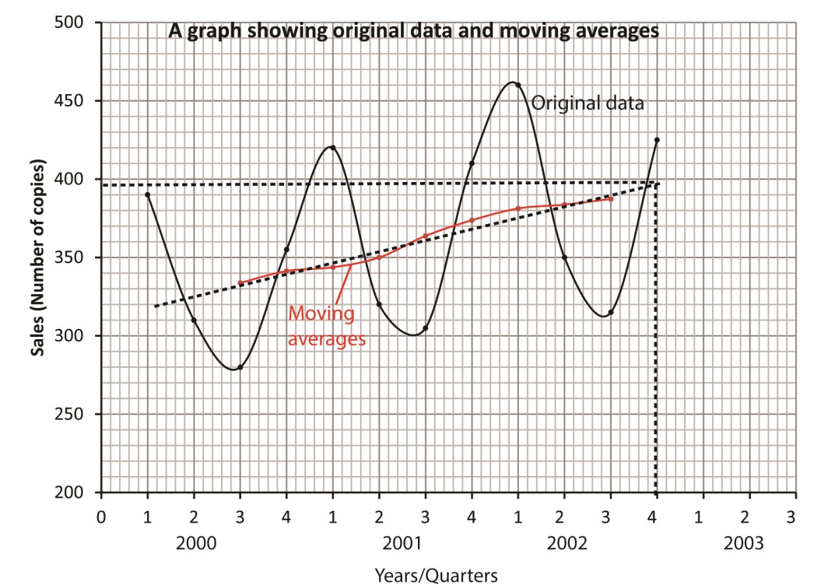
  - Comment on the trend of the sales of the cars. (01 mark)
There is a general increase in the sale of cars with the years
  - Use your graph to estimate the number of cars sold in the first quarter of 2003. (02marks)
The estimated 10th moving average = 395 cars
Let the number of cars sold in the 1st quarter of 2003 be x
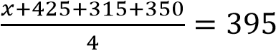
x + 1,115 = 395 x 4 =1580 x = 490

Example 3
The table below shows the 3-month moving averages for the quantity of good (in tonnes) manufactured by a certain company from January to August of 2019.
Month | February | March | April | May | June | July
3-month Moving  Average (tonnes) | 15 | 17.5 | 19 | 20 | 21.5 | 22.5
- Find the moving totals. (03marks)

Solution
Month | Tax | Moving  totals
Jan
February |  | 45 | 15
March |  | 52.5 | 17.5
April |  | 57 | 19
May |  | 60 | 20
June |  | 64.5 | 21.5
July |  | 67.5 | 22.5

- If 20 tonnes and 10 tonnes of goods were manufactured in February and March respectively, calculate the quantity that was manufactured in January. (02 marks)

Solution
Let the quantity manufactured in January be x x + 20 + 10 = 45 x + 30 = 45 x = 15

Example 5
The table shows the number of bags of sugar sold by a certain wholesale shop from the year 2009 to 2020
YEAR | QUARTER
YEAR | 1ST | 2nd | 3rd | 4th
2009 | 192 | 280 | 320 | 260
2010 | 300 | 360 | 380 | 270
2011 | 342 | 420 | 430 | 320
2012 | 424 | 480 | 510 | 412
- Calculate the four-point averages for the data (06marks)
 | Year | Quarter | Bags sold | Moving  Totals | Moving averages
2009 |  | 1st | 192
 |  | 2nd | 280
 |  | 3rd | 320 | 1052 | 263
 |  | 4th | 260 | 1160 | 290
2010 |  | 1st | 300 | 1240 | 310
 |  | 2nd | 360 | 1300 | 325
 |  | 3rd | 380 | 1310 | 328
 |  | 4th | 270 | 1352 | 338
2011 |  | 1st | 342 | 1412 | 353
 |  | 2nd | 420 | 1462 | 367
 |  | 3rd | 430 | 1512 | 378
 |  | 4th | 320 | 1594 | 399
2012 |  | 1st | 424 | 1654 | 414
 |  | 2nd | 480 | 1734 | 434
 |  | 3rd | 510 | 1826 | 457
 |  | 4th | 412
2013 |  | 1st | x

- (i) On the same axes, plot the original data and the four-point moving averages. (05 marks)
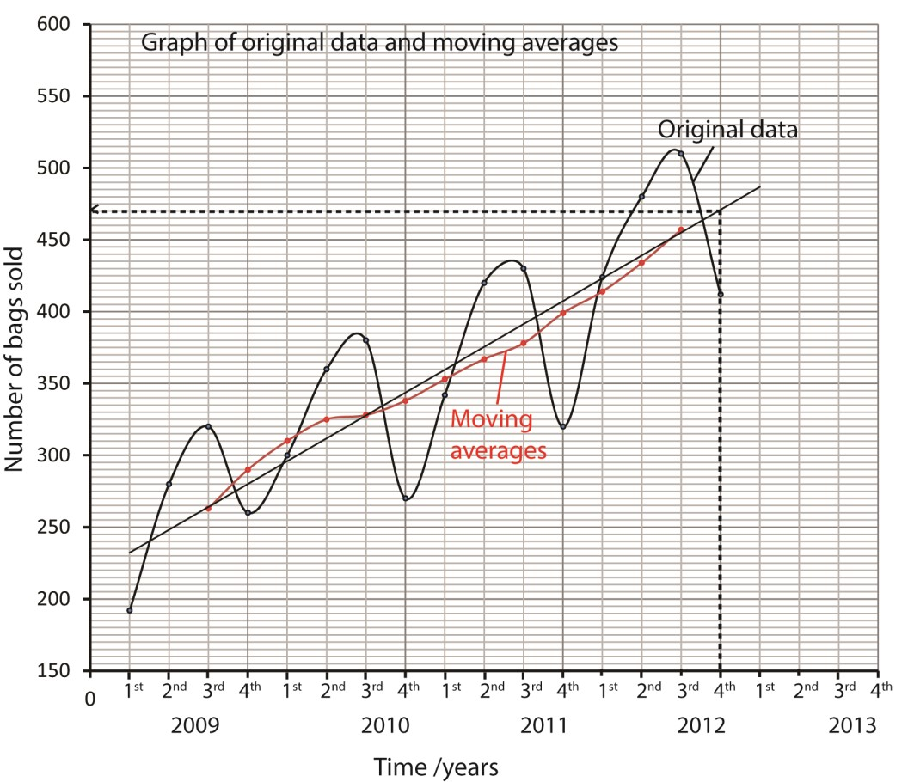
  - Comment on the trends of the number of bags of sugar sold over the four year period. (01 mark)
There is a general increase in the number of bags sold with increase in time
  - Use your graph to estimate the number of bags to be sold in the first quarter of 2013. (03marks)
The estimates 14th moving average = 460
Let the number of bags sold in the first quarter of 2013 be x
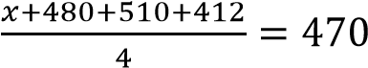
x = 1,880 – 1402 = 478

Example 6
The table shows the sales in thousands of copies by a local Newspaper over a period of 12 weeks.
Week | 1 | 2 | 3 | 4 | 5 | 6 | 7 | 8 | 9 | 10 | 11 | 12
Number of copies sold | 135 | 378 | 490 | 430 | 510 | 580 | 565 | 595 | 640 | 660 | 628 | 670
- Calculate the 3-weeks moving averages for the copies sold. (06marks)
week | Number of copies | Moving totals | Moving averages
1 | 315
2 | 378 | 1183 | 394.3
3 | 490 | 1298 | 476.7
3 | 430 | 1430 | 476.7
5 | 510 | 1520 | 506.7
6 | 580 | 1655 | 551.7
7 | 565 | 1740 | 580
8 | 595 | 1800 | 600
9 | 640 | 1895 | 631.7
10 | 660 | 1928 | 642.7
11 | 628 | 1958 | 652.7
12 | 670
13 | x
- (i) On the same axes, plot the original data and the 3-weeks moving averages. (06marks)
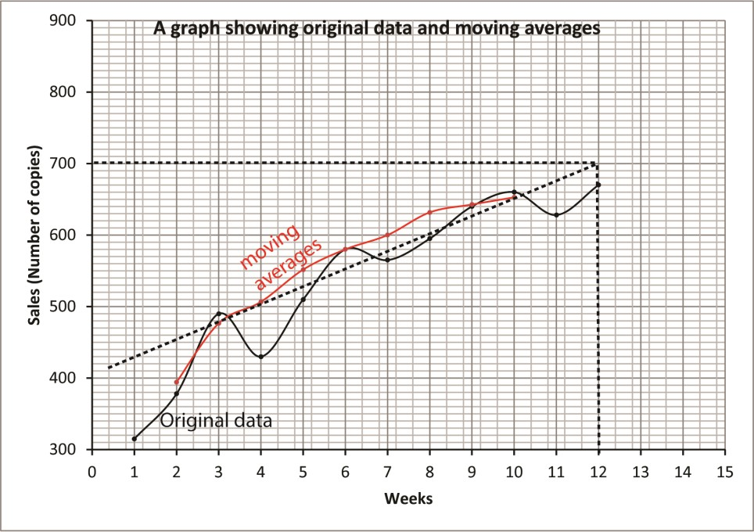
(ii) Use your graphs to estimate the number of copies sold in the 13th week. (03marks)
From the graph the 11th moving average = 700
Let x be the number of copies sold in the 13th week
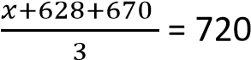; x = (700x3) – (628 + 670) = 802

Example 7
The table below shows the tax collection of a town council in millions of shillings for six consecutive months.
Month | Jan | Feb | Mar | Apr | May | June
Tax (in millions) | 21.5 | 24.3 | 21.8 | 26.2 | 22.7 | 28.9
- Construct the 3-month moving average for the given data. (06marks) Solution
Month | Jan | Feb | March | April | May | June | July
Tax | 21.5 | 24.3 | 21.8 | 26.2 | 22.7 | 28.9 | x
Moving  totals |  | 67.6 | 72.3 | 70.7 | 77.8
Moving averages |  | 22.5 | 24.1 | 23.6 | 25.9

- Plot the 3-month moving averages and the original data on the same axes. (06 marks)
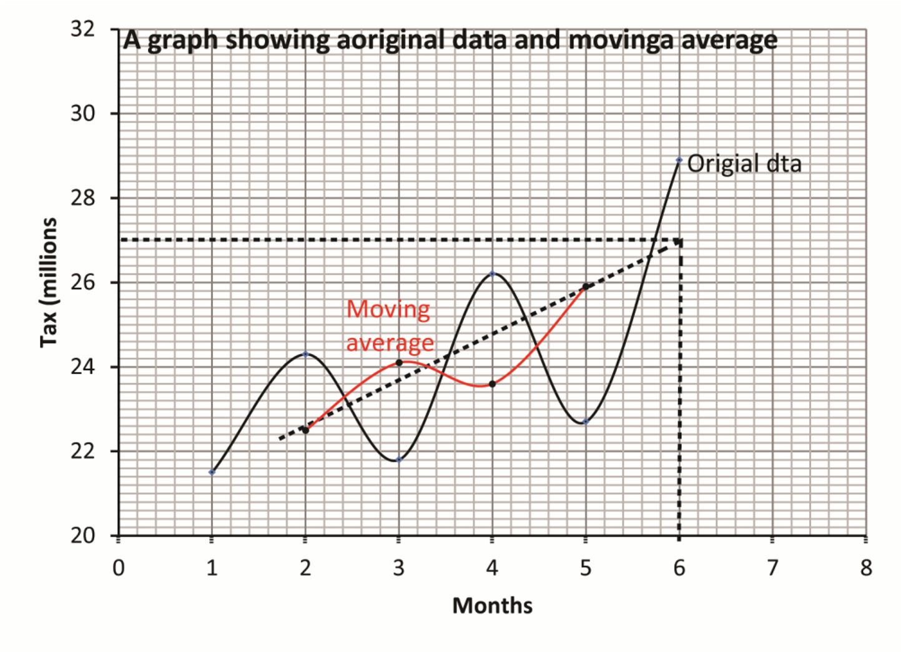
- Use your graph to estimate the town council’s tax collection for the month of July. (03marks)
From the graph the moving average for June = 27 millions
If x are the sales for July
Then 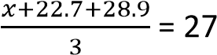
x + 51 = 81 x = 30
Defining the trend of the moving averages
The trend of moving average is indicated by the line of the best fit. For the sake of uniformity, the line of the best fit is drawn through the first and last moving average.
- A line of the best fit sloping up from left to right shows a general increase in production, sales, performance etc.

- A line of the best fit sloping down from left to right shows a general decrease in production, sales, performance etc.

- A line of best fit that is horizontal (parallel to x-axis) shows constant production, performance, sales.

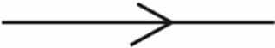

Revision exercise 1
- The table below shows the tax collection of a town council in millions of shillings for 8 consecutive months of a given year.
months | 1 | 2 | 3 | 4 | 5 | 6 | 7 | 8
sales | 60 | 45 | 52 | 40 | 45 | 42 | 35 | 48
  - Construct a four year moving average
  - Plot a graph of the moving averages together with the original data.
  - Comment on the trend of sales over 8month period. [general decline of sales over eight months]
- The table below shows the termly marks scored in mathematics by a certain student in four years of secondary school.
Year | 1st | 2nd | 3rd
1 | 36 | 50 | 54
2 | 40 | 45 | 60
3 | 39 | 46 | 70
4 | 49 | 50 | x
  - Construct the 3-month moving average for the given data
  - On the same axes, plot the original data and the 3-month moving averages.
  - Use your graphs to estimate the mark x scored in term 3 year 4. [45%]
- The sales of brand A ina supermarket for a period of five years are given in the table below
Year | 1 | 2 | 3 | 4 | 5
sales | 230 | 241 | 259 | 272 | 288
  - Construct the 3-month moving average for the given data
  - On the same axes, plot the original data and the 3-year moving averages.
  - Use your graphs to estimate the sales of the 6th year [45%]

Price indices
Index numbers are statistical measures that show trends in a variable or group of variable with time. In Economic they are commonly used to calculate changes in prices.
Terms Used
Base year (P₀) is a year or period when prices of items considered being stable or it is a reference year
Current year (P_{n}) is a year for which the indices are to be computed
Types of price indices
- Price relative (P,R) 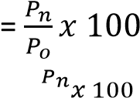
- Simple price index = 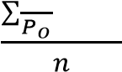
- Simple Aggregate Price Index (S.A.PI) = 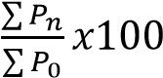
- the weighted price index = 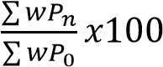

Examples 8
The table below shows the prices of items and their corresponding weights in the years 2000 and 2004
Item | Price (U Shs) |  | Weight
Item | 2000 | 2004 | Weight
Food | 55,000 | 60,000 | 4
Housing | 48,000 | 52,000 | 2
Transport | 16,000 | 20,000 | 1
Using 2000as the base year calculate the weighted price index for the items in 2004. (05 marks)
W.P.I =

Examples 9
The table below shows the expenditure in shillings of University student for the years 2005 and 2006.
ITEM | EXPENDITURE(Shs) |  | WEIGHT
ITEM | 2005 | 2006 | WEIGHT
Text books | 100,000 | 120,000 | 3
Pocket money | 50,000 | 70,000 | 2
Research | 40,000 | 50,000 | 1
Using the year 2005 as the base, calculate the weighted aggregate price index. (05marks)
Weighted aggregate index 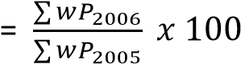
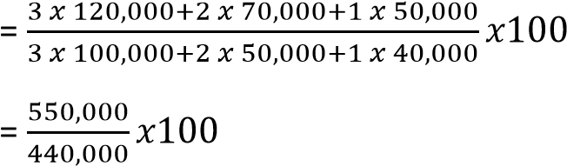
= 125

Examples 10
The table below shows the expenditure of a family for the months of January and July in a certain year.
Item | Expenditure (Shs) |  | Weight
Item | January | July | Weight
Food | 150,000 | 174,000 | 8
Rent | 50,000 | 60,000 | 2
Clothing | 100,000 | 125,000 | 6
Power | 20,000 | 25,000 | 1
Water | 60,000 | 90,000 | 4
- Calculate the:
  - Price relative for each item (03 marks)
Solution
Price relative = 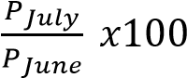
Price relative for food = 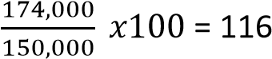
Price relative for rent = 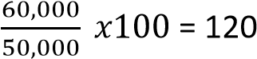
Price relative for clothing = 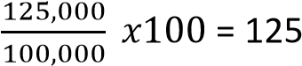
Price relative for Power = 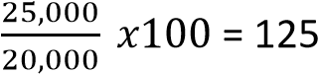
Price relative for Water = 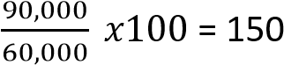

  - Simple aggregate index (04 marks)
Solution
Simple aggregate index 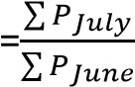
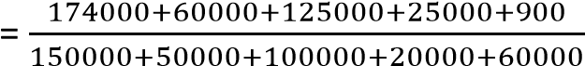
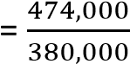
= 1.25
- (i) find the weighted aggregate price index. (06 marks) Solution
Weighed aggregate price index 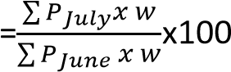
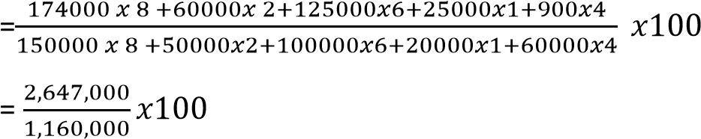
= 123

(ii) comment on your result in (b) (i) (02marks) Prices increased by 23%

Examples 11
The table below shows the prices in US dollars and weights of five components of an engine, in 1998 and 2005.
COMPONENT | A | B | C | D | E
PRICE ($) 1998 | 35 | 70 | 43 | 180 | 480
PRICE ($) 2005 | 60 | 135 | 105 | 290 | 800
WEIGHT | 6 | 5 | 3 | 2 | 1
Taking 1998 as the base year
- Calculate for 2005the:
  - simple aggregate price index. (03marks)
S.A.P.I =
  - price relative of each component. (03marks)
Price relative = 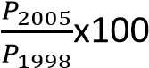
Price relative for A = 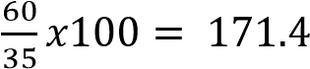
Price relative for B = 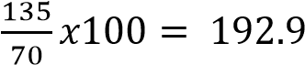 Price relative for C = 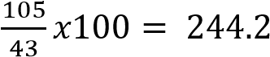
Price relative for D = 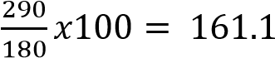
Price relative for E = 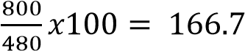
  - weighted aggregate price index. (06marks)
W.A.P.I =
- Estimate the cost of an engine in 1998 given that its cost in 2005 was 1600 US dollars
Method 1: using S.A.P.I
Let x be the cost
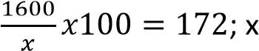= 930.2 US dollars
Method 2 Using W.A.P.I
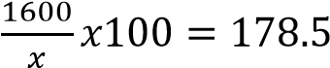; x= 896.4 US dollars

Examples 12
The table below shows the price (in Ug Shs) of some food Items in January, June and December together with the corresponding weights.
Item | Price (in Ug Shs) |  |  | Weight
Item | January | June | December | Weight
Matooke (1 bunch) | 15,000 | 13,000 | 18,000 | 4
Meat (1kg) | 6,500 | 6000 | 7,150 | 1
Posho(1kg) | 2,000 | 1,800 | 1,600 | 3
Beans (1kg) | 2,200 | 2,000 | 2,860 | 2
- Simple aggregate price index for June
S.A.P.I =
Comment on your results (05 marks)
There was a general decrease in the prices of items in the month of June by 11.29%
- Weighted aggregate price index for December
W.A.P.I =
Comment on your results (10 marks)
There was a general increase in the prices of items in the month of December by 11.29% Examples 13
- The table below shows the price (U shs) of flour and eggs in the years of 2000 and 2010
COMMODITY | PRICE (U shs)
COMMODITY | 2000 | 2010
Flour | 3000 | 5000
Eggs (1tray) | 5000 | 7000
Taking 2000 as the base year, calculate the:
  - Price relative of each commodity
Price relative = 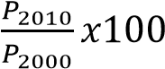
Price relative for flour = 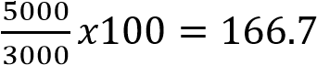
Price relative for eggs = 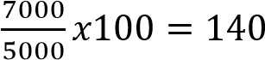
  - Simple aggregate price index
S.A.P.I = 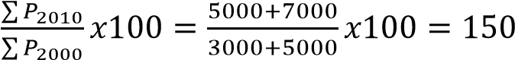
Comment on your results (08marks)
The prices of items increased by 50% from 2000 to 2010

- The data below shows items with their corresponding prices relatives and weights
ITEM | PRICE RELATIVE | WEIGHT
Food | 120 | 172
Clothing | 124 | 160
Housing | 125 | 170
Transport | 135 | 210
Others | 104 | 140
  - Find the cost of living index
Cost of living index = weighted price index
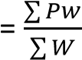 where p = price relative, w = weights
ITEM | PRICE  RELATIVE(P) | WEIGHT  (w) | Pw
Food | 120 | 172 | 20640
Clothing | 124 | 160 | 19840
Housing | 125 | 170 | 21250
Transport | 135 | 210 | 28350
Others | 104 | 140 | 14560
SUM |  | 852 | 104640
Cost of living index =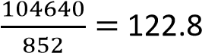
  - Comment on your result . (07 marks) The cost of living increased by 22.8%

Revision Exercise 2
- The cost of making a cake is calculated from the cost of baking flour, sugar, milk and eggs. All these ingredients are measured in kg. The table below gives the cost of these items in year 1 and year 2
ITEM (kg) | Price |  | Weight
ITEM (kg) | Year 1 | Year 2 | Weight
Flour | 60 | 78 | 20640
Sugar | 50 | 40 | 19840
Milk | 25 | 30 | 21250
Eggs | 10 | 15 | 28350
Using year 1 as base year
  - (i) Calculate the price relative for each item.
Hence find simple price index for the cost of making a cake.[120]
(ii) Find the weighted aggregate price index for the cost of making a cake. [118]
  - If the cost of making a cake in year 2 was shs 30. Find the cost in year 1 using the two indices. [25, 25.5]
- The table below shows the price of commodities in year 1 and year 2 per kg
ITEM (kg) | Price
ITEM (kg) | Year 1 | Year 2
Flour | 1200 | 1800
Sugar | 1300 | 2000
Milk | 800 | 1300
Eggs | 700 | 1000
Find
  - Price relative of each item in year 2 using year 1 as base year
  - Simple aggregate price index in year 2 using year 1 as base year [152.5]

Year | Year1 |  | Year 2
Year | Price  (shs) | weight | Price  (shs) | weight
Chips | 800 | 12 | 950 | 10
Bread | 350 | 6 | 300 | 7
Cake | 250 | 4 | 280 | 5
Fruit | 350 | 8 | 430 | 8
- Given below are prices of food items and their corresponding weights in Year 1 and year 2
Omelette | 500 | 9 | 600 | 10
Tea | 300 | 10 | 300 | 12
Liver | 1500 | 15 | 1600 | 12
Using year 1 as base year, calculate
    - Price relative of each item
    - The simple price index of the items [110]
    - Weighted aggregate price index for year 2 [101]

